ТОГДА / СЕЙЧАС
Памятник на углу улиц Карпинского и Никитина
42.88460, 74.62256
Тогда · Frunze
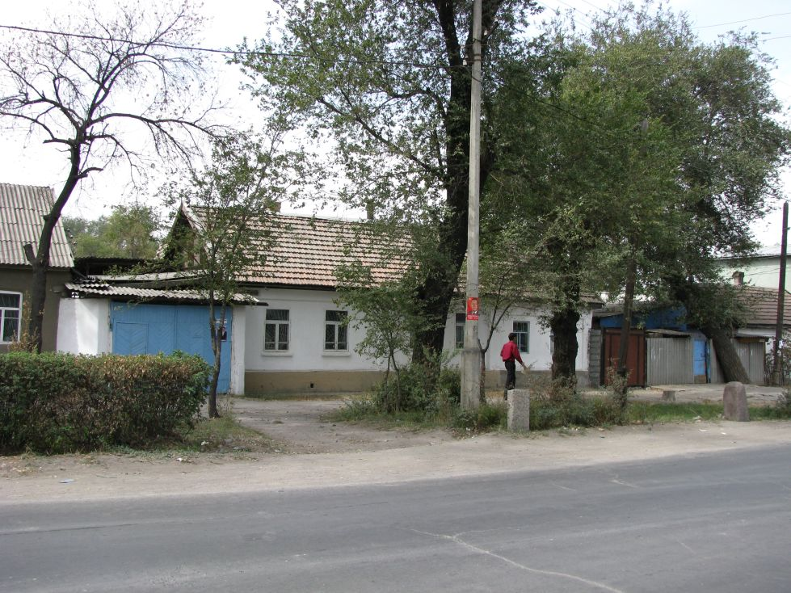
Сейчас · Bishkek


PISHPEK
No information has been found for this period yet
42.88460, 74.62256

Фотография пока не добавлена
ENGLISH
No information has been found for this period yet.

FRUNZE
Monument on the corner of Karpinsky and Nikitin streets
42.88460, 74.62256
Памятник на углу улиц Карпинского и Никитина · Евгения Коровина
ENGLISH Monument on the corner of Karpinsky and Nikitin streets
﻿ Monument on the corner of Karpinsky (Suyumbaeva) and Nikitin streets Monument on the corner of Karpinsky (Suyumbaeva) and Nikitin streets. Miraculously surviving tombstone from the old Christian cemetery from the grave of a railway worker. The cemetery functioned until 1935. Subsequently, a park was laid out on its territory and the Issyk-Kul cinema was built. An entire generation of the first settlers of the city of Pishpek - Frunze was buried
Source: https://bimap.su/description/frunze/527_Pamiatnik.txt · BIMAP
Фотографии и материалы принадлежат их авторам; лицензия не указана

BISHKEK
No information has been found for this period yet
42.88460, 74.62256
Фотография пока не добавлена
ENGLISH
No information has been found for this period yet.

