ТОГДА / СЕЙЧАС
Дом на Советской
42.86778, 74.61159
Тогда · Frunze
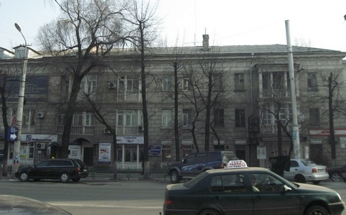
Сейчас · Bishkek


PISHPEK
No information has been found for this period yet
42.86778, 74.61159

Фотография пока не добавлена
ENGLISH
No information has been found for this period yet.

FRUNZE
House on Sovetskaya
42.86778, 74.61159
Дом на Советской · Владимира Петрова
ENGLISH House on Sovetskaya
﻿ House on Sovetskaya On September 20, 1939, this 3-storey residential building on Sovetskaya Street was put into operation. Architect A.M. Albansky. The design of the building used the flat pictorial ornament of the sgraffito technique and openwork plaster gratings on the loggias.
Source: https://bimap.su/description/frunze/526_Sovetskaia1939.txt · BIMAP
Фотографии и материалы принадлежат их авторам; лицензия не указана

BISHKEK
No information has been found for this period yet
42.86778, 74.61159
Современный вид; дата публикации в 2GIS · Иманалиев Истамбек
ENGLISH
No information has been found for this period yet.
Source: https://2gis.kg/bishkek/firm/70000001059984676/tab/photos · 2GIS
Фотография пользователя 2GIS; права принадлежат автору. Изображение показывается по внешней ссылке на 2GIS.

