ТОГДА / СЕЙЧАС
Двор в Дунгановке
42.87486, 74.58562
Тогда · Pishpek
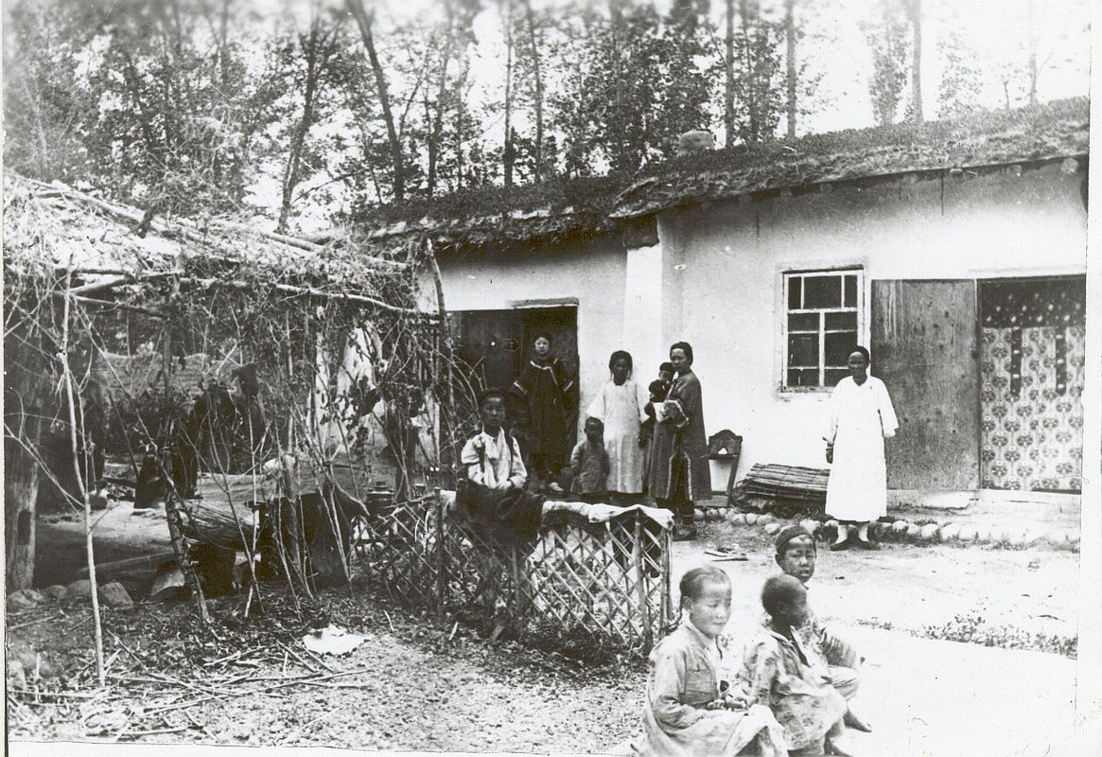
Сейчас · Bishkek


PISHPEK
Yard in Dunganovka
42.87486, 74.58562
Двор в Дунгановке
ENGLISH Yard in Dunganovka
﻿ Yard in Dunganovka. End of the 19th century. In 1882, a large group of Dungan refugees from China arrived in Pishpek. They were accepted into Russian citizenship and settled compactly on the western outskirts of the city of Pishkek, forming the so-called Dungan settlement. Houses built from readily available materials rose within the boundaries of Kazarmennaya, Iskakovskaya, Atbashinskaya and Tashkentskaya. Dungan estates were located here free
Source: https://bimap.su/description/pishpek/73_Dvor_v_Dunganovke.txt · BIMAP
Фотографии и материалы принадлежат их авторам; лицензия не указана

FRUNZE
No information has been found for this period yet
42.87486, 74.58562

Фотография пока не добавлена
ENGLISH
No information has been found for this period yet.

BISHKEK
No information has been found for this period yet
42.87486, 74.58562
Современный вид; дата публикации в 2GIS · mesho4iK
ENGLISH
No information has been found for this period yet.
Source: https://2gis.kg/bishkek/geo/15763234351063403/tab/photos · 2GIS
Фотография пользователя 2GIS; права принадлежат автору. Изображение показывается по внешней ссылке на 2GIS.

