ТОГДА / СЕЙЧАС
Кинотеатр «Иссык-Куль»
42.88477, 74.62043
Тогда · Frunze
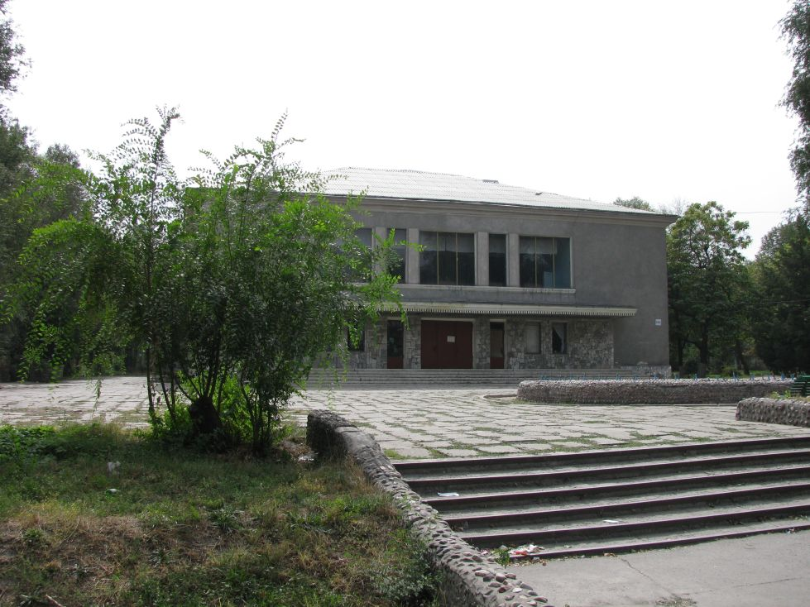
Сейчас · Bishkek


PISHPEK
No information has been found for this period yet
42.88477, 74.62043

Фотография пока не добавлена
ENGLISH
No information has been found for this period yet.

FRUNZE
Cinema "Issyk-Kul"
42.88477, 74.62043
Кинотеатр «Иссык-Куль» · Евгения Коровина
ENGLISH Cinema "Issyk-Kul"
﻿ Cinema "Issyk-Kul" The wide-screen cinema "Issyk-Kul" was opened in 1959. It has two auditoriums with 400 seats each.
Source: https://bimap.su/description/frunze/524_Issykkul.txt · BIMAP
Фотографии и материалы принадлежат их авторам; лицензия не указана

BISHKEK
No information has been found for this period yet
42.88477, 74.62043
Фотография пока не добавлена
ENGLISH
No information has been found for this period yet.

