ТОГДА / СЕЙЧАС
Цеха завода имени В.И.Ленина
42.86316, 74.58189
Тогда · Frunze
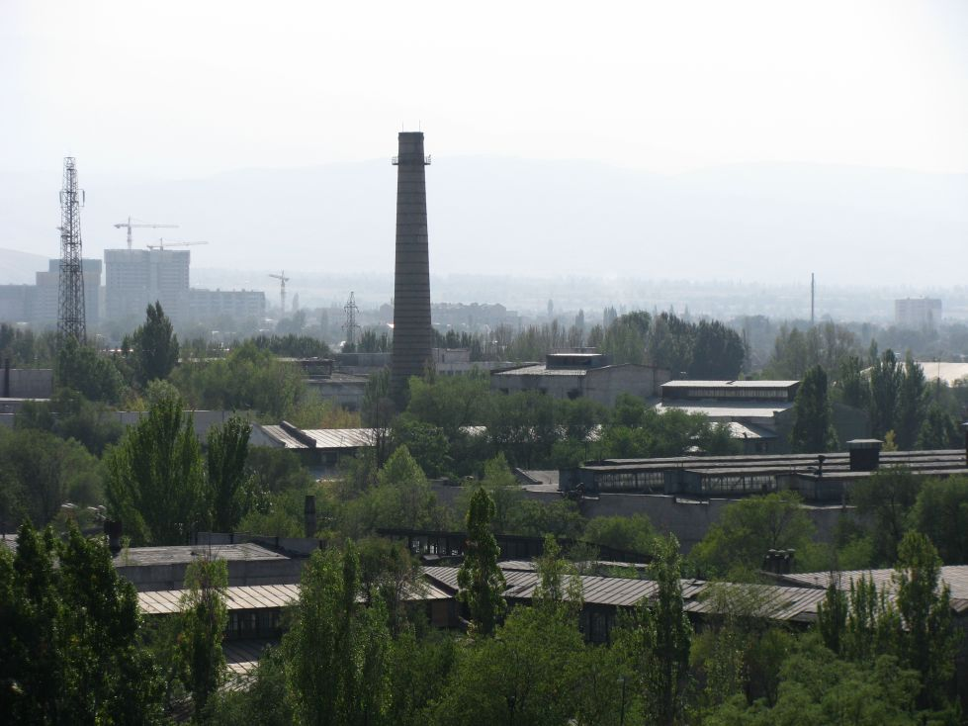
Сейчас · Bishkek


PISHPEK
No information has been found for this period yet
42.86316, 74.58189

Фотография пока не добавлена
ENGLISH
No information has been found for this period yet.

FRUNZE
Shops of the plant named after V.I. Lenin
42.86316, 74.58189
Цеха завода имени В.И.Ленина · Евгения Коровина
ENGLISH Shops of the plant named after V.I. Lenin
﻿ Shops of the plant named after V.I. Lenin Defense plant, evacuated from the city of Voroshilovgrad (Lugansk). It was placed in the unfinished workshops of a worsted and cloth factory. Produced cartridges and mines. In the 90s, he mastered the serial production of high-precision operating machines, hoists and presses, as well as the production of equipment for domestic needs. The plant employed up to 40 thousand workers in the 80s.
Source: https://bimap.su/description/frunze/523_Zavod.txt · BIMAP
Фотографии и материалы принадлежат их авторам; лицензия не указана

BISHKEK
No information has been found for this period yet
42.86316, 74.58189
Современный вид из Wikimedia Commons · Thomas Depenbusch (Depi) from Cologne, Germany
ENGLISH
No information has been found for this period yet.
Source: https://commons.wikimedia.org/wiki/Bishkek_Osh-Bazaar,_Kyrgyzstan_(6100445341).jpg · Wikimedia Commons
Лицензия Wikimedia Commons: CC BY 2.0

