ТОГДА / СЕЙЧАС
Пивзавод на Заводской
42.87322, 74.57084
Тогда · Frunze
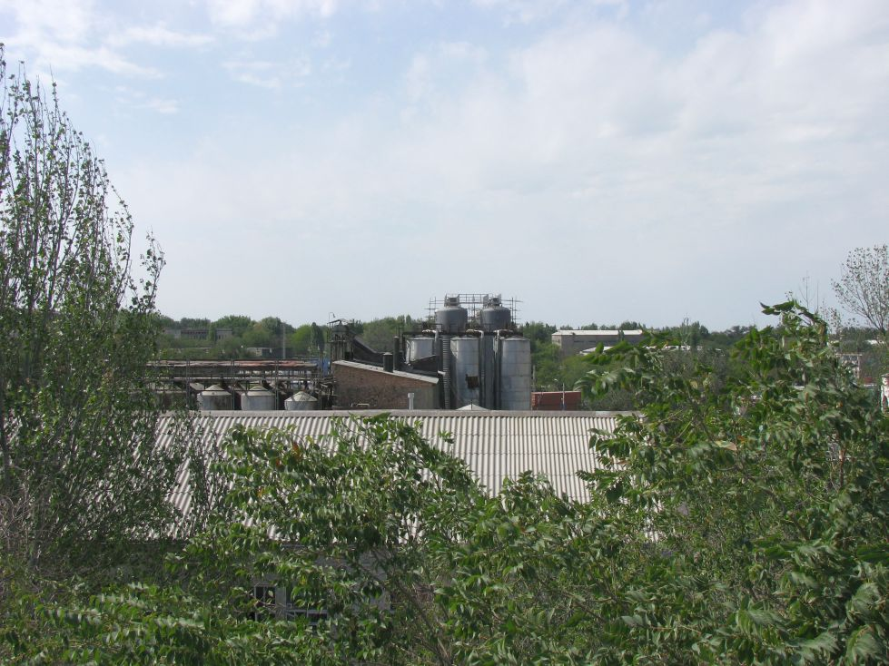
Сейчас · Bishkek


PISHPEK
No information has been found for this period yet
42.87322, 74.57084

Фотография пока не добавлена
ENGLISH
No information has been found for this period yet.

FRUNZE
Brewery on Zavodskaya
42.87322, 74.57084
Пивзавод на Заводской · Евгения Коровина
ENGLISH Brewery on Zavodskaya
﻿ Brewery on Zavodskaya Frunzensky brewery was built in 1908. In the 50s, an automatic beer bottling line was introduced. It produces 6 types of beer - Zhigulevskoe, Rizhskoe, Kirgizskoe, Frunzenskoe, Barley Ear, Moskovskoe, and 13 types of soft drinks. Number of employees: 218 people.
Source: https://bimap.su/description/frunze/521_Pivzavod.txt · BIMAP
Фотографии и материалы принадлежат их авторам; лицензия не указана

BISHKEK
No information has been found for this period yet
42.87322, 74.57084
Современный вид; дата публикации в 2GIS · Almazbek Abdyrakhmanov
ENGLISH
No information has been found for this period yet.
Source: https://2gis.kg/bishkek/geo/15763234351118618/tab/photos · 2GIS
Фотография пользователя 2GIS; права принадлежат автору. Изображение показывается по внешней ссылке на 2GIS.

