ТОГДА / СЕЙЧАС
Здание на бывшей Пушкинской
42.87728, 74.59210
Тогда · Frunze
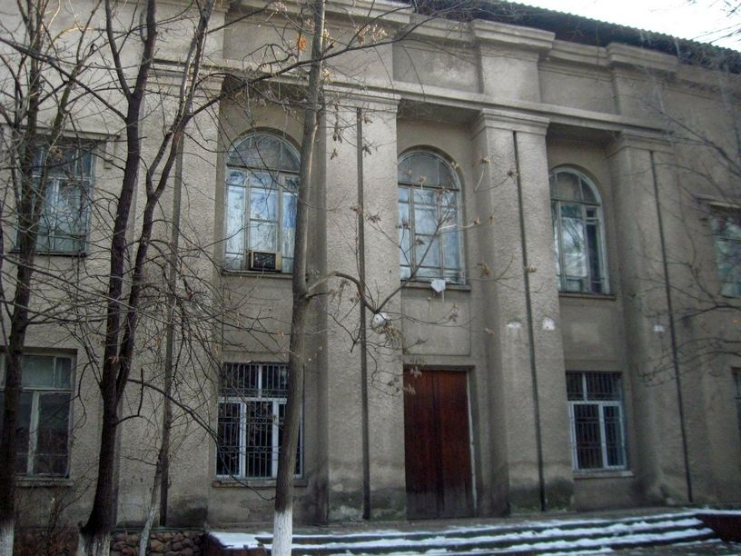
Сейчас · Bishkek


PISHPEK
No information has been found for this period yet
42.87728, 74.59210

Фотография пока не добавлена
ENGLISH
No information has been found for this period yet.

FRUNZE
Building on the former Pushkinskaya
42.87728, 74.59210
Здание на бывшей Пушкинской · Владимира Петрова
ENGLISH Building on the former Pushkinskaya
﻿ Building on the former Pushkinskaya The newspaper “Soviet Kyrgyzstan” announced on September 10, 1939 that a land management technical school had opened on Pushkin (Georgievskaya) Street. In fact, the former Pushkinskaya was already called Molotov Street since 1938. Then it was called 40 years of October (now Isanova). This building was not a technical school for long. With the beginning of the Great Patriotic War, a rear hospital was deployed
Source: https://bimap.su/description/frunze/518_Teknikum.txt · BIMAP
Фотографии и материалы принадлежат их авторам; лицензия не указана

BISHKEK
No information has been found for this period yet
42.87728, 74.59210
Современный вид; дата публикации в 2GIS · Ринат Ибрагимов
ENGLISH
No information has been found for this period yet.
Source: https://2gis.kg/bishkek/geo/15763234351107867/tab/photos · 2GIS
Фотография пользователя 2GIS; права принадлежат автору. Изображение показывается по внешней ссылке на 2GIS.

