ТОГДА / СЕЙЧАС
Здание ЧУПРА
42.88059, 74.58901
Тогда · Pishpek
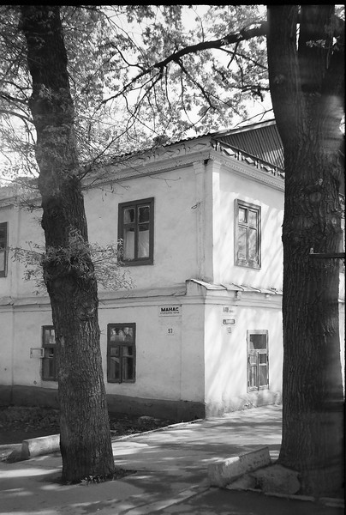
Сейчас · Bishkek


PISHPEK
CHUPR House
42.88059, 74.58901
Дом ЧУПР · Владимира Петрова
ENGLISH CHUPR House
﻿ CHUPR House at the beginning of the 20th century. Significant development of construction work in Pishpek and the Chu Valley was associated with the beginning of design and survey work and the creation in Pishpek of the CHUPRA-Chuya Directorate for Irrigation of the Chu River Valley. The construction of dams, canals, and main ditches began. Since 1910, under the leadership of engineer V.A. Vasilyev, research, design and construction work began
Source: https://bimap.su/description/pishpek/72_Dom_CUPRA.txt · BIMAP
Фотографии и материалы принадлежат их авторам; лицензия не указана

FRUNZE
CHUPRA building
42.88059, 74.58901
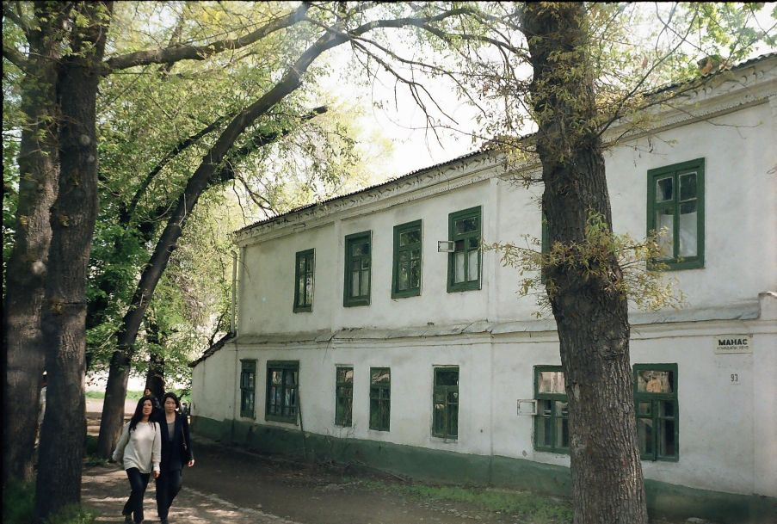
Здание ЧУПРА · Владимира Петрова
ENGLISH CHUPRA building
﻿ CHUPRA building. Photo by Vladimir Petrov The CHUPRA office was located here - the office of the head of irrigation works in the Chu River valley.
Source: https://bimap.su/description/frunze/115_Dom_Chupra.txt · BIMAP
Фотографии и материалы принадлежат их авторам; лицензия не указана

BISHKEK
No information has been found for this period yet
42.88059, 74.58901
Современный вид; дата публикации в 2GIS · Askat Dostukov
ENGLISH
No information has been found for this period yet.
Source: https://2gis.kg/bishkek/geo/15763234351115138/tab/photos · 2GIS
Фотография пользователя 2GIS; права принадлежат автору. Изображение показывается по внешней ссылке на 2GIS.

