ТОГДА / СЕЙЧАС
Магазин Акчурина
42.88190, 74.61139
Тогда · Pishpek
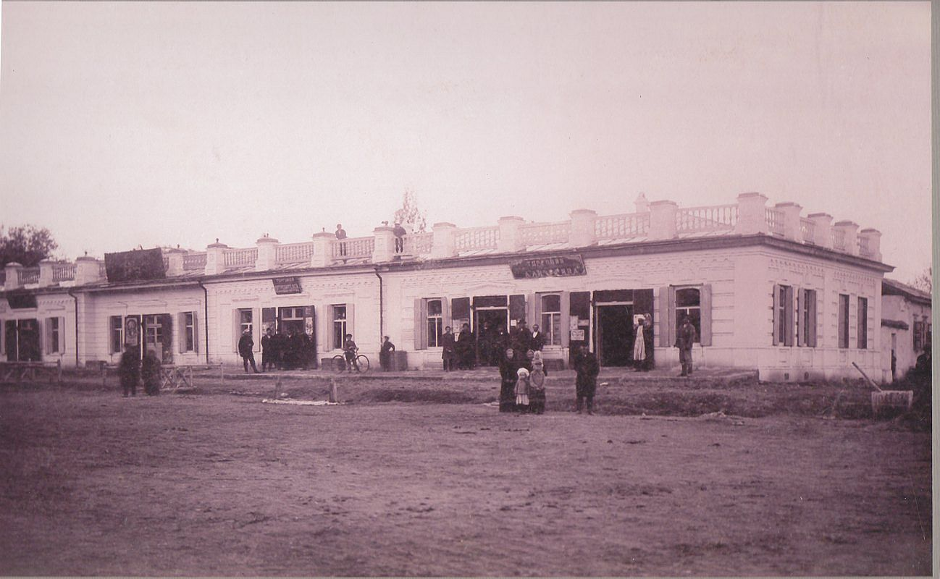
Сейчас · Bishkek


PISHPEK
Akchurin's Store
42.88190, 74.61139
Магазин Акчурина
ENGLISH Akchurin's Store
﻿ Akchurin's Store Among the numerous stationary retail outlets of Pishpek, the number of which exceeded 500, large trading establishments of merchants and industrialists stood out. In the shopping arcades of Bazarnaya Street there were shops of merchants A. Akchurin, I. Daulbaev, A. Pushnikov, N. Ivanov, A. Kveitman and others. The import of industrial products and goods was carried out from Russia through Tashkent and by caravan routes through
Source: https://bimap.su/description/pishpek/7_Magazin_Akchurina.txt · BIMAP
Фотографии и материалы принадлежат их авторам; лицензия не указана

FRUNZE
No information has been found for this period yet
42.88190, 74.61139

Фотография пока не добавлена
ENGLISH
No information has been found for this period yet.

BISHKEK
No information has been found for this period yet
42.88190, 74.61139
Современный вид; дата публикации в 2GIS · Rus Rus
ENGLISH
No information has been found for this period yet.
Source: https://2gis.kg/bishkek/firm/70000001020302132/tab/photos · 2GIS
Фотография пользователя 2GIS; права принадлежат автору. Изображение показывается по внешней ссылке на 2GIS.

