ТОГДА / СЕЙЧАС
Ала-Арчинское кладбище
42.88305, 74.57184
Тогда · Frunze
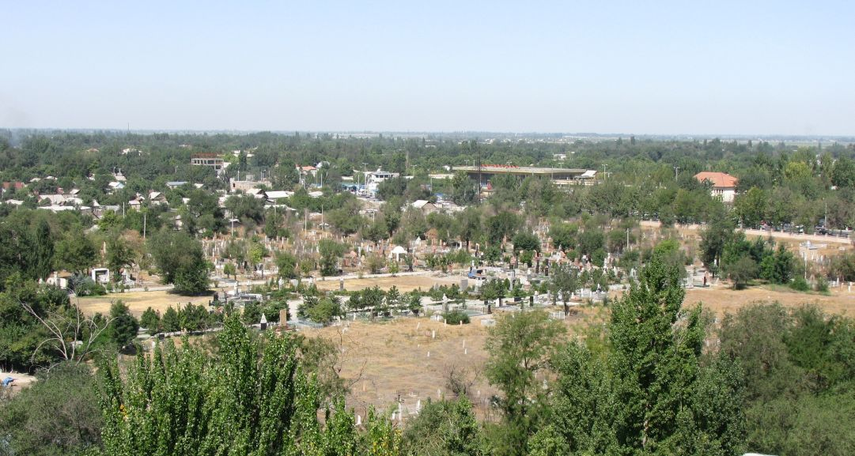
Сейчас · Bishkek


PISHPEK
No information has been found for this period yet
42.88305, 74.57184

Фотография пока не добавлена
ENGLISH
No information has been found for this period yet.

FRUNZE
Ala-Archinskoe Cemetery
42.88305, 74.57184
Ала-Арчинское кладбище · Евгения Коровина
ENGLISH Ala-Archinskoe Cemetery
﻿ Ala-Archinskoe Cemetery Has memorial areas with the graves of famous people, which are monuments of the history and culture of the city.
Source: https://bimap.su/description/frunze/495_AlaArcha.txt · BIMAP
Фотографии и материалы принадлежат их авторам; лицензия не указана

BISHKEK
No information has been found for this period yet
42.88305, 74.57184
Современный вид из Wikimedia Commons · A.Savin
ENGLISH
No information has been found for this period yet.
Source: https://commons.wikimedia.org/wiki/Bishkek_03-2016_img29_Ala-Archinskoe_Cemetery.jpg · Wikimedia Commons
Лицензия Wikimedia Commons: FAL

