ТОГДА / СЕЙЧАС
Магазины на Советской
42.88141, 74.61143
Тогда · Frunze
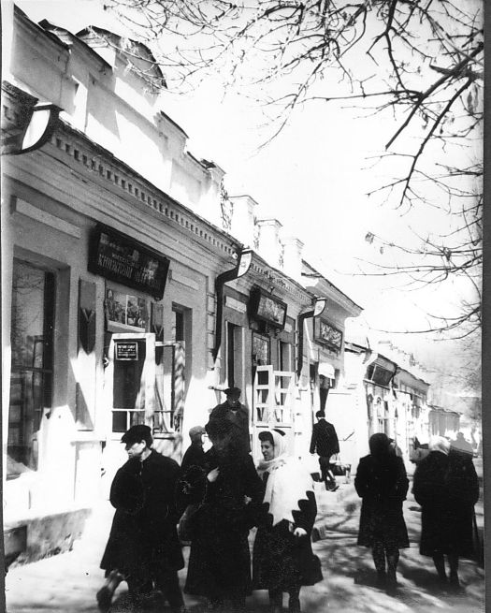
Сейчас · Bishkek


PISHPEK
No information has been found for this period yet
42.88141, 74.61143

Фотография пока не добавлена
ENGLISH
No information has been found for this period yet.

FRUNZE
Shops on Sovetskaya
42.88141, 74.61143
Магазины на Советской
ENGLISH Shops on Sovetskaya
﻿ Shops on Sovetskaya. Photo from 1940. “Today, of course, nothing reminds us of the street that was once called Bazarnaya. "Siberian trade and industrial yearbook 1914-1915." called it, along with some others, the “most central” street. And there were reasons for this then. Here, on the section from Tokmakskaya Street (Zhumabek to Uyezdnaya (Abdumomunova)), merchant shops and shops were grouped together. On the site of the new building of the li
Source: https://bimap.su/description/frunze/493_MagSov.txt · BIMAP
Фотографии и материалы принадлежат их авторам; лицензия не указана

BISHKEK
No information has been found for this period yet
42.88141, 74.61143
Современный вид; дата публикации в 2GIS · Фотография от 2ГИС
ENGLISH
No information has been found for this period yet.
Source: https://2gis.kg/bishkek/firm/70000001103539022/tab/photos · 2GIS
Фотография пользователя 2GIS; права принадлежат автору. Изображение показывается по внешней ссылке на 2GIS.

