ТОГДА / СЕЙЧАС
Улица Советская
42.87356, 74.61158
Тогда · Frunze

Сейчас · Bishkek


PISHPEK
No information has been found for this period yet
42.87356, 74.61158

Фотография пока не добавлена
ENGLISH
No information has been found for this period yet.

FRUNZE
Sovetskaya Street
42.87356, 74.61158
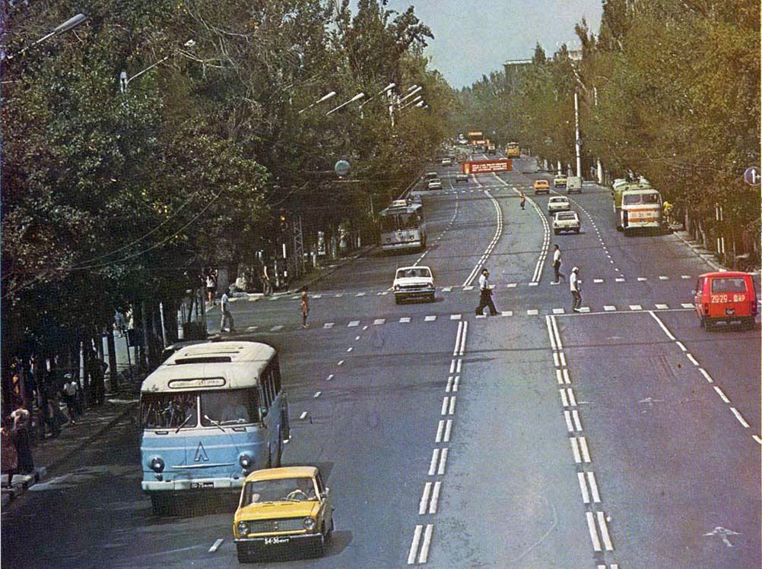
Улица Советская
ENGLISH Sovetskaya Street
﻿ Sovetskaya Street Sovetskaya Street (Abdrakhmanova) is one of the main thoroughfares of the city, connecting its old and new parts and passing through the entire city from south to north. Today it has been renamed and divided into several sections, but all the early townspeople stubbornly call it Soviet. On Sovetskaya Street there are: Children's Park, the head enterprise of the May 1 garment production association, the Opera and Ballet Theater
Source: https://bimap.su/description/frunze/491_Sovet.txt · BIMAP
Фотографии и материалы принадлежат их авторам; лицензия не указана

BISHKEK
No information has been found for this period yet
42.87356, 74.61158
Современный вид; дата публикации в 2GIS · Мирбек Ts
ENGLISH
No information has been found for this period yet.
Source: https://2gis.kg/bishkek/firm/70000001090577673/tab/photos · 2GIS
Фотография пользователя 2GIS; права принадлежат автору. Изображение показывается по внешней ссылке на 2GIS.

