ТОГДА / СЕЙЧАС
Кукольный театр «Золотой ключик»
42.88671, 74.60990
Тогда · Frunze
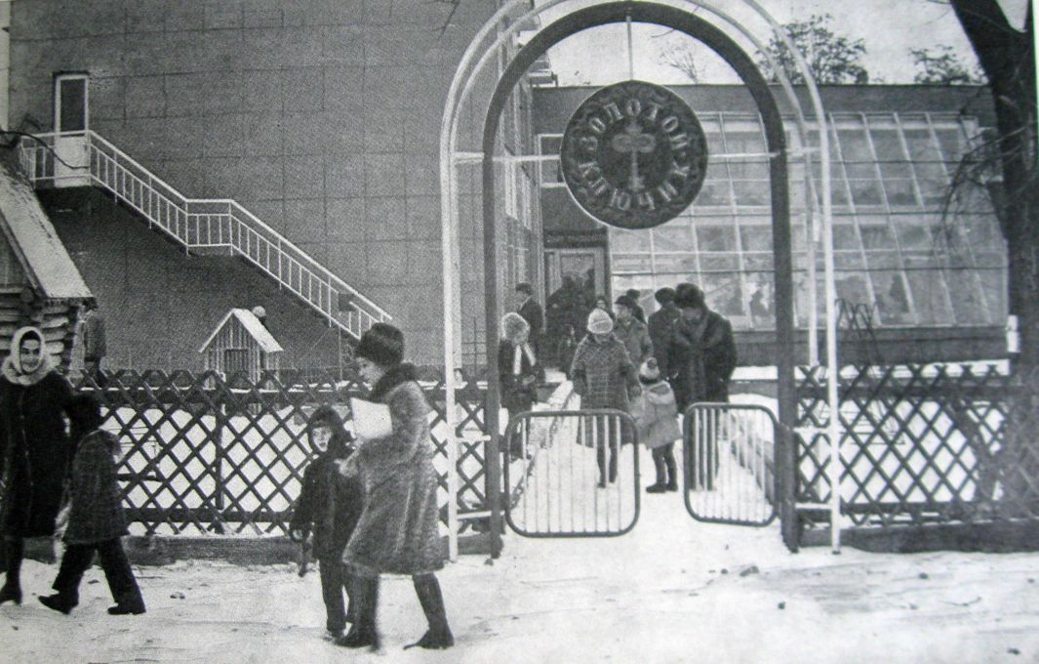
Сейчас · Bishkek


PISHPEK
No information has been found for this period yet
42.88671, 74.60990

Фотография пока не добавлена
ENGLISH
No information has been found for this period yet.

FRUNZE
Puppet theater "Golden Key"
42.88671, 74.60990
Кукольный театр «Золотой ключик»
ENGLISH Puppet theater "Golden Key"
﻿ Puppet theater "Golden Key". Photo from the album “City of Frunze”, 1978. The puppet theater did not have its own building and was located either in the mosque building, or in the “Lux” store, or in the building of the Ministry of Agriculture. In the 70s it was located in the Palace of Pioneers.
Source: https://bimap.su/description/frunze/482_Kukolnyi1978.txt · BIMAP
Фотографии и материалы принадлежат их авторам; лицензия не указана

BISHKEK
No information has been found for this period yet
42.88671, 74.60990
Современный вид; дата публикации в 2GIS · ఇ fiw
ENGLISH
No information has been found for this period yet.
Source: https://2gis.kg/bishkek/firm/70000001019329791/tab/photos · 2GIS
Фотография пользователя 2GIS; права принадлежат автору. Изображение показывается по внешней ссылке на 2GIS.

