ТОГДА / СЕЙЧАС
Аллея героев
42.87695, 74.57581
Тогда · Frunze
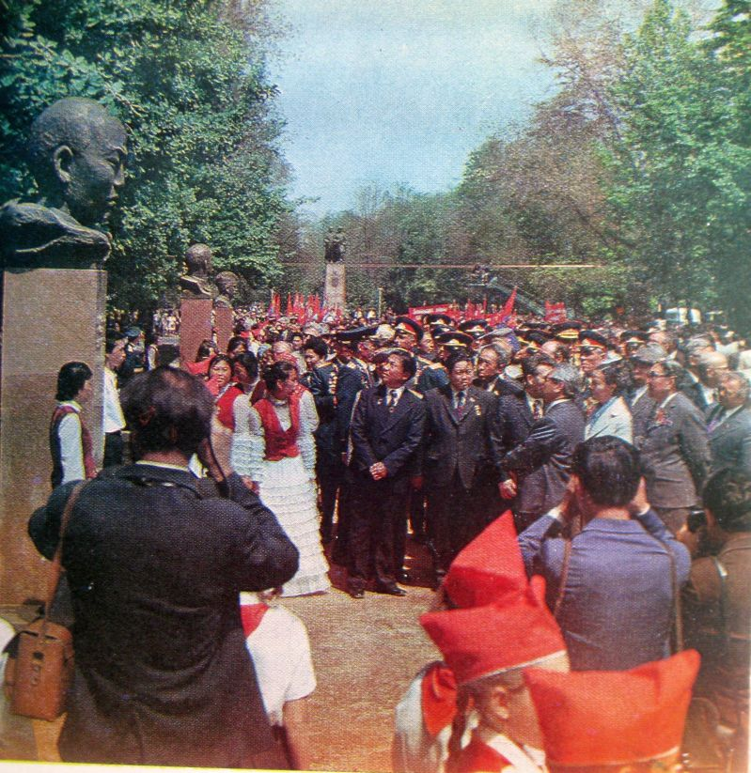
Сейчас · Bishkek


PISHPEK
No information has been found for this period yet
42.87695, 74.57581

Фотография пока не добавлена
ENGLISH
No information has been found for this period yet.

FRUNZE
Alley of Heroes
42.87695, 74.57581
Аллея героев
ENGLISH Alley of Heroes
﻿ Alley of Heroes The memorial was opened in 1975 in honor of the 30th anniversary of the Victory of the Soviet people over Nazi Germany. 6 busts of Heroes of the Soviet Union N.Ya. Ananyev, G.E. Konkin, I.V. Moskalenko, G.A. Petrenko, Ch. Tuleberdiev, D. Shopokov were installed. Photo from the album “City of Frunze”, 1978. On the memorial plate are the names of Kyrgyzstanis - Heroes of the Soviet Union and full holders of the Order of Glory. Pho
Source: https://bimap.su/description/frunze/477_Alleia_geroev.txt · BIMAP
Фотографии и материалы принадлежат их авторам; лицензия не указана

BISHKEK
No information has been found for this period yet
42.87695, 74.57581
Современный вид; дата публикации в 2GIS · А.А As.
ENGLISH
No information has been found for this period yet.
Source: https://2gis.kg/bishkek/geo/15763294480498848/tab/photos · 2GIS
Фотография пользователя 2GIS; права принадлежат автору. Изображение показывается по внешней ссылке на 2GIS.

