ТОГДА / СЕЙЧАС
Улица Васильевская
42.87899, 74.60462
Тогда · Pishpek
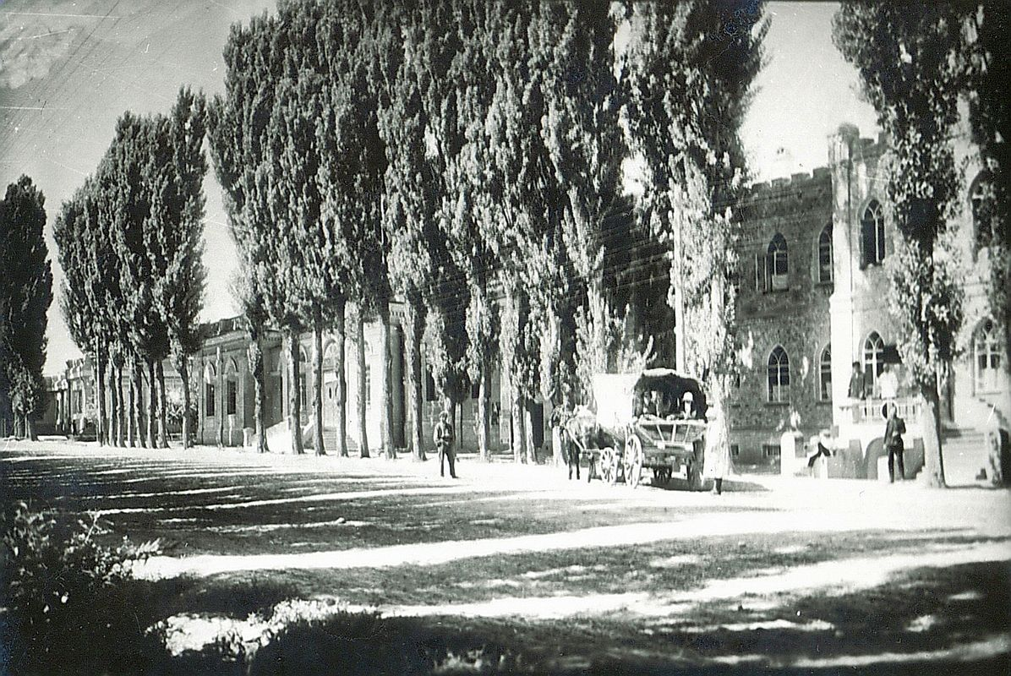
Сейчас · Bishkek


PISHPEK
Vasilyevskaya Street
42.87899, 74.60462
Улица Васильевская
ENGLISH Vasilyevskaya Street
﻿ Western side of Vasilyevskaya Street, 30s of the twentieth century. Houses built according to the design of the architect A.P. Zenkov In 1926, construction began on several significant buildings designed by the architect Andrei Pavlovich Zenkov, with which the history of the city of Pishpek ends. On Vasilievskaya Street these were the buildings of a hotel and an agricultural bank. A.P. Zenkov was the first builder to combine national colors in
Source: https://bimap.su/description/pishpek/68_Zapadnaia_Vasilev.txt · BIMAP
Фотографии и материалы принадлежат их авторам; лицензия не указана

FRUNZE
No information has been found for this period yet
42.87899, 74.60462

Фотография пока не добавлена
ENGLISH
No information has been found for this period yet.

BISHKEK
No information has been found for this period yet
42.87899, 74.60462
Современный вид; дата публикации в 2GIS · Ринат Ибрагимов
ENGLISH
No information has been found for this period yet.
Source: https://2gis.kg/bishkek/geo/15763294480498712/tab/photos · 2GIS
Фотография пользователя 2GIS; права принадлежат автору. Изображение показывается по внешней ссылке на 2GIS.

