ТОГДА / СЕЙЧАС
Дом на Дзержинской
42.86628, 74.60520
Тогда · Frunze
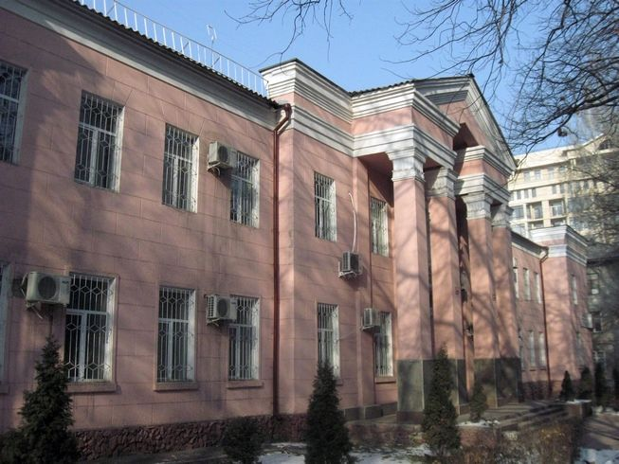
Сейчас · Bishkek


PISHPEK
No information has been found for this period yet
42.86628, 74.60520

Фотография пока не добавлена
ENGLISH
No information has been found for this period yet.

FRUNZE
House on Dzerzhinskaya
42.86628, 74.60520
Дом на Дзержинской · Владимира Петрова
ENGLISH House on Dzerzhinskaya
﻿ House on Dzerzhinskaya The construction of this building on Dzerzhinsky Boulevard began before the Great Patriotic War. With the outbreak of the war, construction was hastily completed and evacuated families from the front-line areas were housed in the house. Today this building houses the National Red Crescent Society.
Source: https://bimap.su/description/frunze/472_Dom_na_Dzer.txt · BIMAP
Фотографии и материалы принадлежат их авторам; лицензия не указана

BISHKEK
No information has been found for this period yet
42.86628, 74.60520
Современный вид; дата публикации в 2GIS · B А
ENGLISH
No information has been found for this period yet.
Source: https://2gis.kg/bishkek/firm/70000001019371758/tab/photos · 2GIS
Фотография пользователя 2GIS; права принадлежат автору. Изображение показывается по внешней ссылке на 2GIS.

