ТОГДА / СЕЙЧАС
Дом на Дзержинской
42.86765, 74.60527
Тогда · Frunze
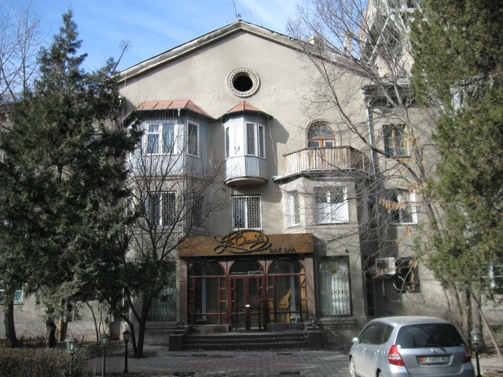
Сейчас · Bishkek


PISHPEK
No information has been found for this period yet
42.86765, 74.60527

Фотография пока не добавлена
ENGLISH
No information has been found for this period yet.

FRUNZE
House on Dzerzhinskaya
42.86765, 74.60527
Дом на Дзержинской
ENGLISH House on Dzerzhinskaya
﻿ House on Dzerzhinskaya built in the 50s Academician Evdokia Aleksandrovna Rozova lived in this house. E.A. Rozova 1899 - 1971 seismologist, academician of the Kyrgyz Academy of Sciences. SSR. As a result of her work, earthquakes were analyzed, the structure of the earth's crust in Central Asia was studied, and the most seismic areas were identified.
Source: https://bimap.su/description/frunze/471_Dom50.txt · BIMAP
Фотографии и материалы принадлежат их авторам; лицензия не указана

BISHKEK
No information has been found for this period yet
42.86765, 74.60527
Современный вид; дата публикации в 2GIS · Ринат Ибрагимов
ENGLISH
No information has been found for this period yet.
Source: https://2gis.kg/bishkek/firm/70000001035355754/tab/photos · 2GIS
Фотография пользователя 2GIS; права принадлежат автору. Изображение показывается по внешней ссылке на 2GIS.

