ТОГДА / СЕЙЧАС
Дом на Киевской
42.87445, 74.60525
Тогда · Frunze
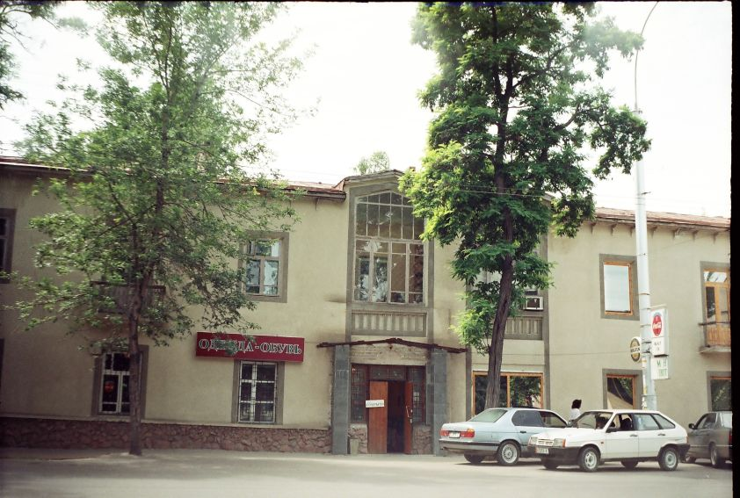
Сейчас · Bishkek


PISHPEK
No information has been found for this period yet
42.87445, 74.60525

Фотография пока не добавлена
ENGLISH
No information has been found for this period yet.

FRUNZE
House on Kievskaya
42.87445, 74.60525
Дом на Киевской · Владимира Петрова
ENGLISH House on Kievskaya
﻿ House on Kievskaya Kyiv Street in the city of Frunze appeared simultaneously with Moskovskaya Street. This is how Dunganskaya and Pionerskaya (Iskhakovskaya) streets began to be called, renamed in 1954 in honor of the 300th anniversary of the reunification of Ukraine with Russia. This two-story house was built in 1954 (architect A. Albansky). Lived in it: The first Kyrgyz geologist, candidate of geological and mineralogical sciences Abdulla Mun
Source: https://bimap.su/description/frunze/470_Dom.txt · BIMAP
Фотографии и материалы принадлежат их авторам; лицензия не указана

BISHKEK
No information has been found for this period yet
42.87445, 74.60525
Современный вид; дата публикации в 2GIS · Айтбек Абдыкаимов
ENGLISH
No information has been found for this period yet.
Source: https://2gis.kg/bishkek/geo/15763234351164126/tab/photos · 2GIS
Фотография пользователя 2GIS; права принадлежат автору. Изображение показывается по внешней ссылке на 2GIS.

