ТОГДА / СЕЙЧАС
Институт леса и ореховодства
42.91590, 74.62126
Тогда · Frunze
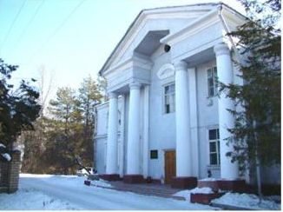
Сейчас · Bishkek


PISHPEK
No information has been found for this period yet
42.91590, 74.62126

Фотография пока не добавлена
ENGLISH
No information has been found for this period yet.

FRUNZE
Institute of Forest and Walnut Growing
42.91590, 74.62126
Институт леса и ореховодства
ENGLISH Institute of Forest and Walnut Growing
﻿ Institute of Forest and Walnut Growing The Kyrgyz forest experimental station rose on the northern outskirts of Karagacheva Grove in 1947. Since 1990, it has been the Institute of Forestry and Walnut Growing of the National Academy of Sciences of the Kyrgyz Republic, now bearing the name of P.A. Gan. “One of the most important objects of nature conservation is forests, and this is no coincidence. The importance of forests in human life, in the
Source: https://bimap.su/description/frunze/469_Les.txt · BIMAP
Фотографии и материалы принадлежат их авторам; лицензия не указана

BISHKEK
No information has been found for this period yet
42.91590, 74.62126
Современный вид; дата публикации в 2GIS · Abdy Jum
ENGLISH
No information has been found for this period yet.
Source: https://2gis.kg/bishkek/geo/15763234351002328/tab/photos · 2GIS
Фотография пользователя 2GIS; права принадлежат автору. Изображение показывается по внешней ссылке на 2GIS.

