ТОГДА / СЕЙЧАС
Токмакская между улицами Базарной и Верненской
42.88227, 74.61239
Тогда · Pishpek
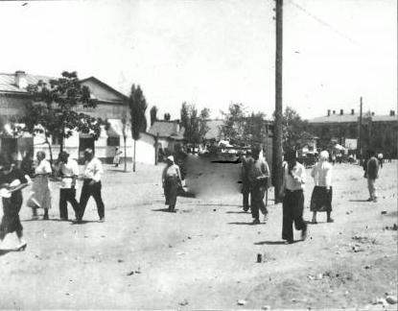
Сейчас · Bishkek


PISHPEK
Tokmakskaya between Bazarnaya and Vernenskaya streets
42.88227, 74.61239
Токмакская между улицами Базарной и Верненской
ENGLISH Tokmakskaya between Bazarnaya and Vernenskaya streets
﻿ The northern side of Tokmakskaya street between Bazarnaya and Vernenskaya. Along Tokmakskaya Street there was an outbuilding attached to Pushnikov’s house. In which the entrepreneur's store was located.
Source: https://bimap.su/description/pishpek/67_Severnaia_Tokmak.txt · BIMAP
Фотографии и материалы принадлежат их авторам; лицензия не указана

FRUNZE
No information has been found for this period yet
42.88227, 74.61239

Фотография пока не добавлена
ENGLISH
No information has been found for this period yet.

BISHKEK
No information has been found for this period yet
42.88227, 74.61239
Современный вид; дата публикации в 2GIS · Азат Камчибеков
ENGLISH
No information has been found for this period yet.
Source: https://2gis.kg/bishkek/geo/15763294480498787/tab/photos · 2GIS
Фотография пользователя 2GIS; права принадлежат автору. Изображение показывается по внешней ссылке на 2GIS.

