ТОГДА / СЕЙЧАС
Парк им.Фучика
42.87287, 74.56258
Тогда · Frunze
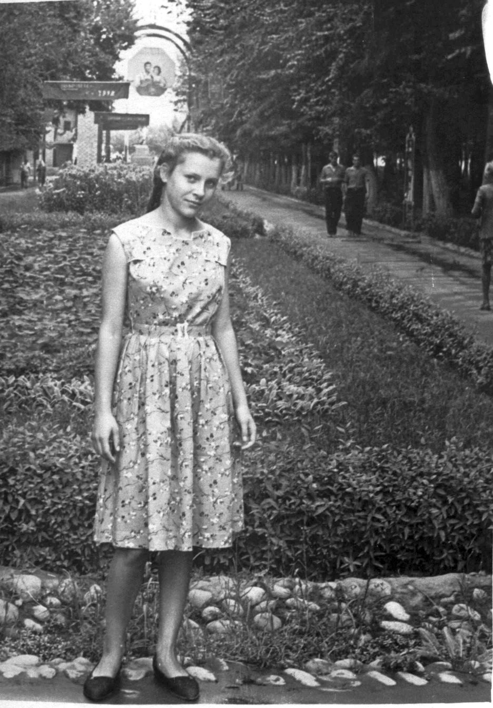
Сейчас · Bishkek


PISHPEK
No information has been found for this period yet
42.87287, 74.56258

Фотография пока не добавлена
ENGLISH
No information has been found for this period yet.

FRUNZE
Fucik Park
42.87287, 74.56258
Парк им.Фучика · 1962 года
ENGLISH Fucik Park
﻿ Fucik Park Fucik Park, photo from 1962. It was founded in 1931 as a park for a working district adjacent to the enterprises of the Intergelpo cooperative. Area 8.5 hectares. The central arch of the entrance to Fucik Park. Photo by Marina Klabukova. The street and park are named after Julius Fučík, a national hero of Czechoslovakia, an anti-fascist, writer and journalist, author of the book “Report with a Noose Around His Neck.” “People, I loved
Source: https://bimap.su/description/frunze/462_Park62.txt · BIMAP
Фотографии и материалы принадлежат их авторам; лицензия не указана

BISHKEK
No information has been found for this period yet
42.87287, 74.56258
Современный вид; дата публикации в 2GIS · Boni Sansaro
ENGLISH
No information has been found for this period yet.
Source: https://2gis.kg/bishkek/geo/15763281595597175/tab/photos · 2GIS
Фотография пользователя 2GIS; права принадлежат автору. Изображение показывается по внешней ссылке на 2GIS.

