ТОГДА / СЕЙЧАС
Дом Пушникова
42.88239, 74.61197
Тогда · Pishpek
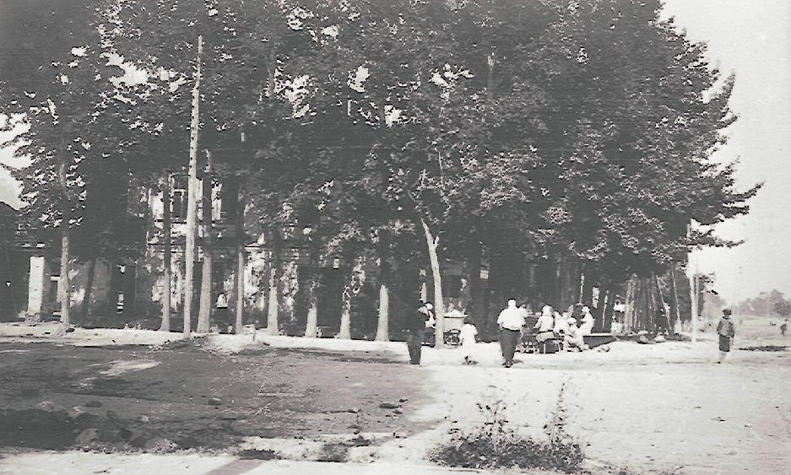
Сейчас · Bishkek


PISHPEK
Pushnikov's House
42.88239, 74.61197
Дом Пушникова
ENGLISH Pushnikov's House
﻿ Pushnikov's House. The north-eastern corner of Tokmak and Bazarnaya The end of the 19th and beginning of the 20th centuries was characterized by the improvement of the city and the construction of large houses at the head of the city estate. The houses stood on high stone foundations made of cobblestones or ashlars, above which there was a brick basement with a patterned decor of the brickwork. The walls of the upper floors are frame-wooden or
Source: https://bimap.su/description/pishpek/66_Dom_Pushnikova.txt · BIMAP
Фотографии и материалы принадлежат их авторам; лицензия не указана

FRUNZE
No information has been found for this period yet
42.88239, 74.61197

Фотография пока не добавлена
ENGLISH
No information has been found for this period yet.

BISHKEK
No information has been found for this period yet
42.88239, 74.61197
Современный вид; дата публикации в 2GIS · Азат Камчибеков
ENGLISH
No information has been found for this period yet.
Source: https://2gis.kg/bishkek/geo/15763294480498787/tab/photos · 2GIS
Фотография пользователя 2GIS; права принадлежат автору. Изображение показывается по внешней ссылке на 2GIS.

