ТОГДА / СЕЙЧАС
Артель «Красный швейник»
42.87614, 74.59130
Тогда · Frunze
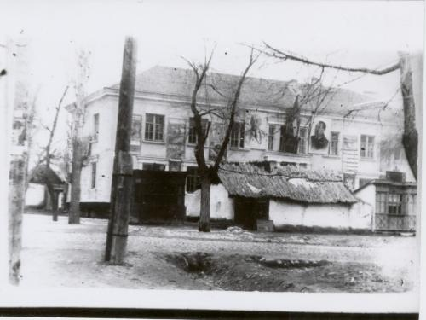
Сейчас · Bishkek


PISHPEK
No information has been found for this period yet
42.87614, 74.59130

Фотография пока не добавлена
ENGLISH
No information has been found for this period yet.

FRUNZE
Artel "Red Sewing Man"
42.87614, 74.59130
Артель «Красный швейник»
ENGLISH Artel "Red Sewing Man"
﻿ Artel "Red Sewing Man" During the Patriotic War, the enterprise "Red Sewing Man" artel, evacuated from Voronezh, was located in this building. In 1956, the artel became a factory; in 1972, the building was demolished, and the factory was merged with the 1 May garment factory.
Source: https://bimap.su/description/frunze/455_KrShveinik.txt · BIMAP
Фотографии и материалы принадлежат их авторам; лицензия не указана

BISHKEK
No information has been found for this period yet
42.87614, 74.59130
Современный вид; дата публикации в 2GIS · Бдительный гражданин
ENGLISH
No information has been found for this period yet.
Source: https://2gis.kg/bishkek/firm/70000001115901898/tab/photos · 2GIS
Фотография пользователя 2GIS; права принадлежат автору. Изображение показывается по внешней ссылке на 2GIS.

