ТОГДА / СЕЙЧАС
Сейсмическая станция «Фрунзе»
42.84105, 74.61262
Тогда · Frunze
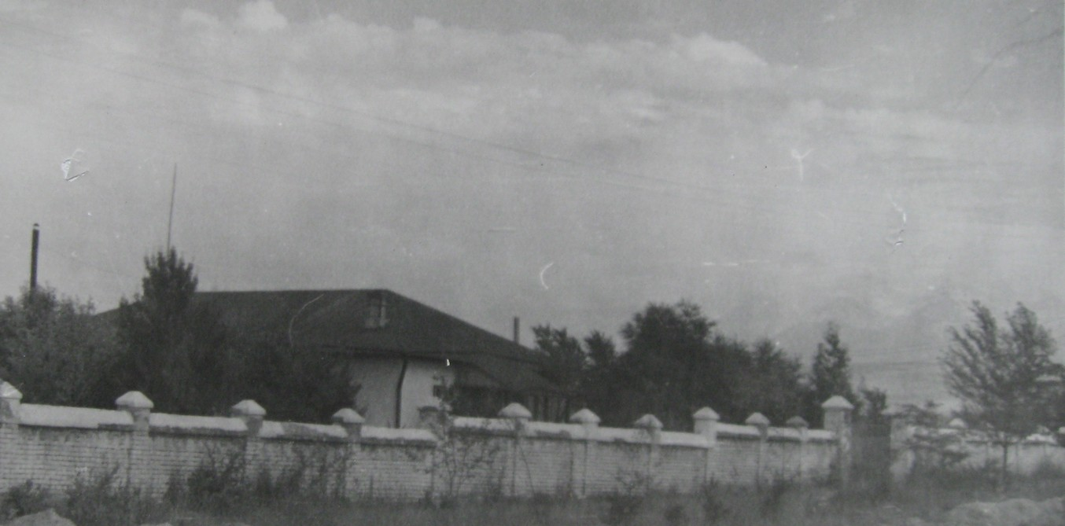
Сейчас · Bishkek


PISHPEK
No information has been found for this period yet
42.84105, 74.61262

Фотография пока не добавлена
ENGLISH
No information has been found for this period yet.

FRUNZE
Seismic station "Frunze"
42.84105, 74.61262
Сейсмическая станция «Фрунзе»
ENGLISH Seismic station "Frunze"
﻿ Seismic station "Frunze". Photo from T.P. Green's album, 1967 The Frunze seismic station was created in 1927 and was originally located in the building of the Council of People's Commissars (Assembly of the People of Kyrgyzstan). After the Ashgabat earthquake, a decision was made to create a network of seismic stations in Kyrgyzstan. In 1954, 3 km from the city of Frunze, this seismic station building, equipped with modern equipment, was built
Source: https://bimap.su/description/frunze/448_Seismika.txt · BIMAP
Фотографии и материалы принадлежат их авторам; лицензия не указана

BISHKEK
No information has been found for this period yet
42.84105, 74.61262
Современный вид; дата публикации в 2GIS · Oks Kir
ENGLISH
No information has been found for this period yet.
Source: https://2gis.kg/bishkek/geo/15763234351140681/tab/photos · 2GIS
Фотография пользователя 2GIS; права принадлежат автору. Изображение показывается по внешней ссылке на 2GIS.

