ТОГДА / СЕЙЧАС
Ботсад
42.85833, 74.59009
Тогда · Frunze
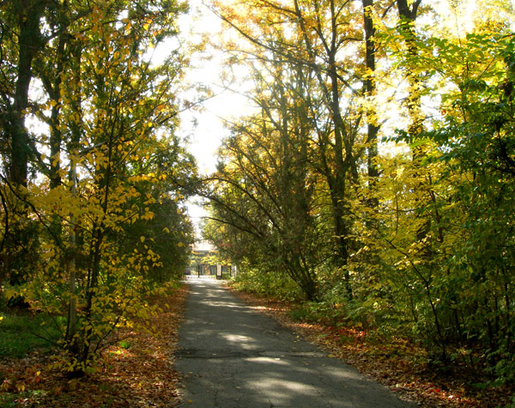
Сейчас · Bishkek


PISHPEK
No information has been found for this period yet
42.85833, 74.59009

Фотография пока не добавлена
ENGLISH
No information has been found for this period yet.

FRUNZE
Botanical garden
42.85833, 74.59009
Ботсад · Виктора Глумского
ENGLISH Botanical garden
﻿ Botanical garden. Arboretum Above the railway, on the solid pebbles of the floodplain of the Ala-Archa River, green quarters of the Botanical Garden were laid out in 1938-39 (founders I.V. Vykhodtsev, E.V. Nikitina, G.P. Svishchev, 1939). The park part of the garden and flower beds are located on 20 hectares. All work was carried out manually, earth was brought in by carts, boulders and cobblestones were taken away. Seeds, cuttings, bulbs, and
Source: https://bimap.su/description/frunze/444_Botsad.txt · BIMAP
Фотографии и материалы принадлежат их авторам; лицензия не указана

BISHKEK
No information has been found for this period yet
42.85833, 74.59009
Современный вид из Wikimedia Commons · Hansjoerg Eberle
ENGLISH
No information has been found for this period yet.
Source: https://commons.wikimedia.org/wiki/Birinchi_May_District,_Bishkek,_Kyrgyzstan_-_panoramio_(1).jpg · Wikimedia Commons
Лицензия Wikimedia Commons: CC BY 3.0

