ТОГДА / СЕЙЧАС
Река Аламедин
42.83936, 74.63257
Тогда · Frunze
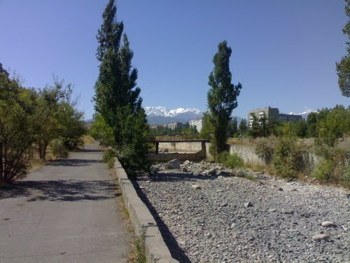
Сейчас · Bishkek


PISHPEK
No information has been found for this period yet
42.83936, 74.63257

Фотография пока не добавлена
ENGLISH
No information has been found for this period yet.

FRUNZE
Alamedin River
42.83936, 74.63257
Река Аламедин
ENGLISH Alamedin River
﻿ Alamedin River in the Botanical Garden area Alamedin River in the Botanical Garden area.
Source: https://bimap.su/description/frunze/439_Alamtdin.txt · BIMAP
Фотографии и материалы принадлежат их авторам; лицензия не указана

BISHKEK
No information has been found for this period yet
42.83936, 74.63257
Современный вид из Wikimedia Commons · Farzona Faizullaeva
ENGLISH
No information has been found for this period yet.
Source: https://commons.wikimedia.org/wiki/Botanical_garden_25.04.2025_9.jpg · Wikimedia Commons
Лицензия Wikimedia Commons: CC BY-SA 4.0

