ТОГДА / СЕЙЧАС
Чайхана
42.87949, 74.61452
Тогда · Pishpek
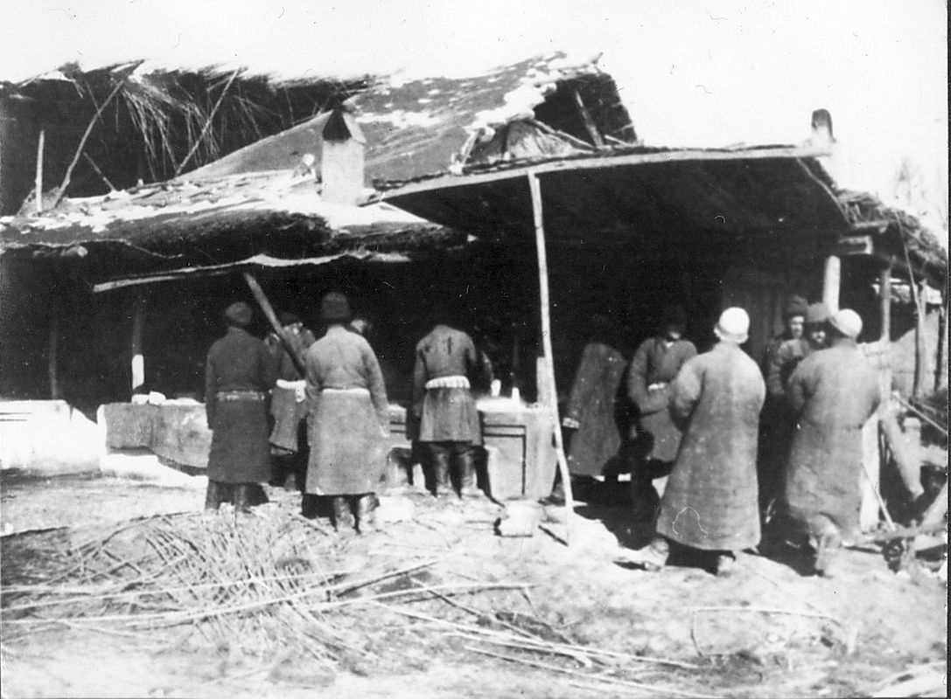
Сейчас · Bishkek


PISHPEK
Teahouse
42.87949, 74.61452
Чайхана
ENGLISH Teahouse
﻿ Teahouse, early twentieth century. Several taverns and teahouses adjoined the market square, where you could have a good meal, relax, and even spend the night.
Source: https://bimap.su/description/pishpek/64_Chaikana.txt · BIMAP
Фотографии и материалы принадлежат их авторам; лицензия не указана

FRUNZE
No information has been found for this period yet
42.87949, 74.61452

Фотография пока не добавлена
ENGLISH
No information has been found for this period yet.

BISHKEK
No information has been found for this period yet
42.87949, 74.61452
Современный вид; дата публикации в 2GIS · Фотография от 2ГИС
ENGLISH
No information has been found for this period yet.
Source: https://2gis.kg/bishkek/firm/70000001082018340/tab/photos · 2GIS
Фотография пользователя 2GIS; права принадлежат автору. Изображение показывается по внешней ссылке на 2GIS.

