ТОГДА / СЕЙЧАС
Проспект Мира
42.83624, 74.58558
Тогда · Frunze
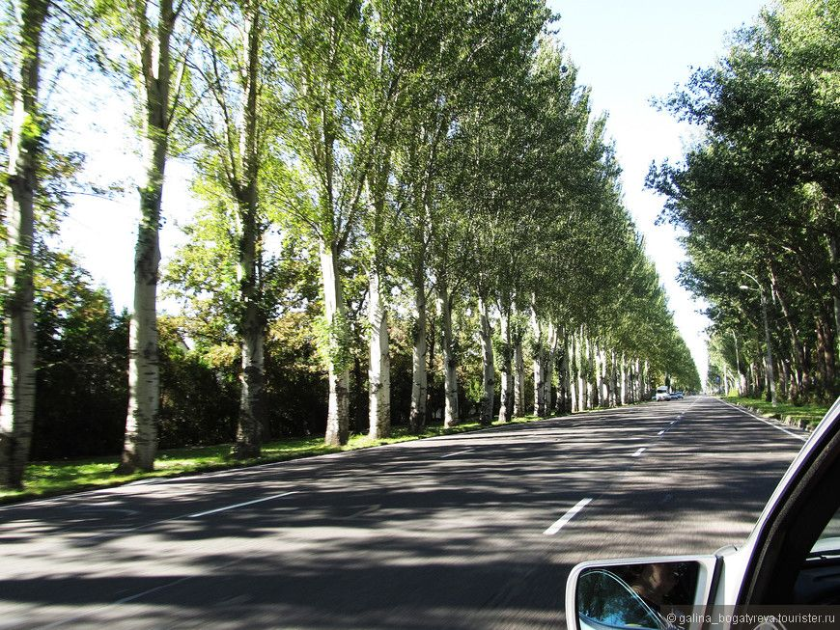
Сейчас · Bishkek


PISHPEK
No information has been found for this period yet
42.83624, 74.58558

Фотография пока не добавлена
ENGLISH
No information has been found for this period yet.

FRUNZE
Mira Avenue
42.83624, 74.58558
Проспект Мира
ENGLISH Mira Avenue
﻿ Mira Avenue In 1960, Novo-Belinskaya Street was renamed Mira Avenue. It stretched from the railway crossing, which came into operation in 1972, to the old Airport. In 1980, the Airport was closed, in connection with the commissioning of the new Manas Airport, the old road was restored and the avenue stretched towards the State Residence and these silver poplars were planted along it.
Source: https://bimap.su/description/frunze/432_Mira.txt · BIMAP
Фотографии и материалы принадлежат их авторам; лицензия не указана

BISHKEK
No information has been found for this period yet
42.83624, 74.58558
Современный вид; дата публикации в 2GIS · Фотография от владельца
ENGLISH
No information has been found for this period yet.
Source: https://2gis.kg/bishkek/firm/70000001091219682/tab/photos · 2GIS
Фотография пользователя 2GIS; права принадлежат автору. Изображение показывается по внешней ссылке на 2GIS.

