ТОГДА / СЕЙЧАС
БГУ
42.85041, 74.58532
Тогда · Frunze
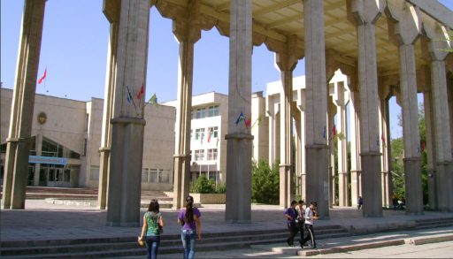
Сейчас · Bishkek


PISHPEK
No information has been found for this period yet
42.85041, 74.58532

Фотография пока не добавлена
ENGLISH
No information has been found for this period yet.

FRUNZE
BSU
42.85041, 74.58532
БГУ
ENGLISH BSU
﻿ BSU Architects U.Alymkulov, O.Lazarev, S.Sultanov, D.Amanaliev, Zh.Zhanaliev. 1985 The history of the Bishkek Humanitarian University dates back to 1979, when the Frunzensky State Pedagogical Institute of Russian Language and Literature was founded and PIRAL was located in the 10th microdistrict. In 1992, the institute was reorganized into the State Institute of Languages ​​and Humanities, and since 1994 - Bishkek Humanitarian University.
Source: https://bimap.su/description/frunze/431_BGU.txt · BIMAP
Фотографии и материалы принадлежат их авторам; лицензия не указана

BISHKEK
No information has been found for this period yet
42.85041, 74.58532
Современный вид; дата публикации в 2GIS · Оставил Отзыв
ENGLISH
No information has been found for this period yet.
Source: https://2gis.kg/bishkek/firm/70000001019352264/tab/photos · 2GIS
Фотография пользователя 2GIS; права принадлежат автору. Изображение показывается по внешней ссылке на 2GIS.

