ТОГДА / СЕЙЧАС
Дортранспроект
42.84889, 74.58708
Тогда · Frunze
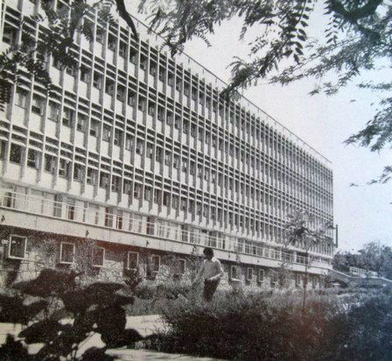
Сейчас · Bishkek


PISHPEK
No information has been found for this period yet
42.84889, 74.58708

Фотография пока не добавлена
ENGLISH
No information has been found for this period yet.

FRUNZE
Dortransproekt
42.84889, 74.58708
Дортранспроект
ENGLISH Dortransproekt
﻿ Dortransproekt Design Institute of Road Transport Construction. Architects G. Kutateladze, K. Sarbanov, R. Moskov. 1973 In the same building there were the Republican Committee of the Trade Union of Motor Transport and Highway Workers and the Institute of Physiology and Experimental Pathology of High Mountains of the Academy of Sciences of the Kyrgyz SSR. Today the building houses the Kyrgyz-Turkish Manas University.
Source: https://bimap.su/description/frunze/426_Dortrans.txt · BIMAP
Фотографии и материалы принадлежат их авторам; лицензия не указана

BISHKEK
No information has been found for this period yet
42.84889, 74.58708
Современный вид; дата публикации в 2GIS · salima kanalbekova
ENGLISH
No information has been found for this period yet.
Source: https://2gis.kg/bishkek/firm/70000001019352779/tab/photos · 2GIS
Фотография пользователя 2GIS; права принадлежат автору. Изображение показывается по внешней ссылке на 2GIS.

