ТОГДА / СЕЙЧАС
Ошский рынок
42.87578, 74.57119
Тогда · Frunze
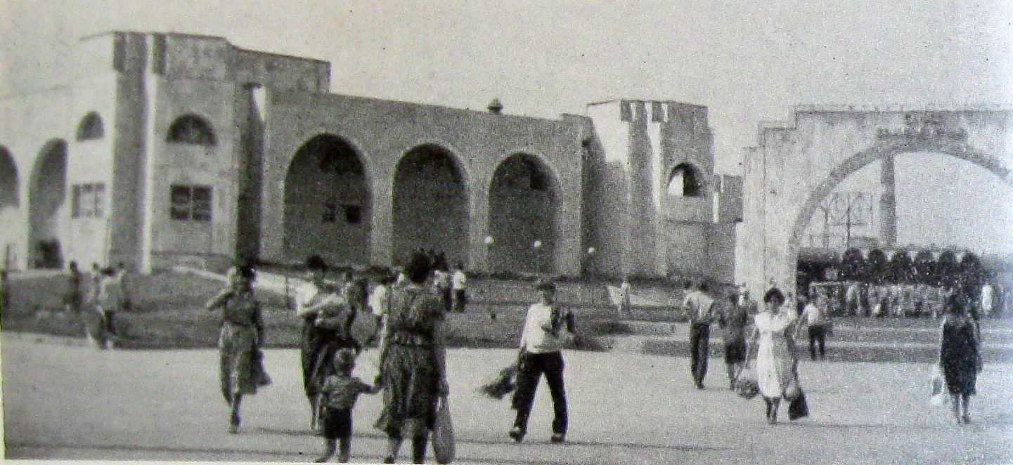
Сейчас · Bishkek


PISHPEK
No information has been found for this period yet
42.87578, 74.57119

Фотография пока не добавлена
ENGLISH
No information has been found for this period yet.

FRUNZE
Osh Market
42.87578, 74.57119
Ошский рынок
ENGLISH Osh Market
﻿ Osh Market Osh Market, formerly called the Soviet Market, was rebuilt in 1983. The architects of the project are A. Nezhurin, Y. Chubarov, K. Nazarov and others. It was erected by the builders of the city of Osh, individual pavilions were built by collective farms of the Osh region, which is why they called it “Osh Bazaar”. The complex is located on an area of ​​5 hectares on the right bank of the river. Ala-Archa. It consists of shopping pavil
Source: https://bimap.su/description/frunze/418_Oshskii.txt · BIMAP
Фотографии и материалы принадлежат их авторам; лицензия не указана

BISHKEK
No information has been found for this period yet
42.87578, 74.57119
Современный вид; дата публикации в 2GIS · Медина Суйутбекова
ENGLISH
No information has been found for this period yet.
Source: https://2gis.kg/bishkek/geo/15763281595596984/tab/photos · 2GIS
Фотография пользователя 2GIS; права принадлежат автору. Изображение показывается по внешней ссылке на 2GIS.

