ТОГДА / СЕЙЧАС
Восточный автовокзал
42.88708, 74.62975
Тогда · Frunze
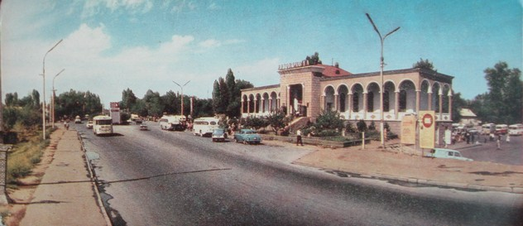
Сейчас · Bishkek


PISHPEK
No information has been found for this period yet
42.88708, 74.62975

Фотография пока не добавлена
ENGLISH
No information has been found for this period yet.

FRUNZE
Eastern bus station
42.88708, 74.62975
Восточный автовокзал
ENGLISH Eastern bus station
﻿ Eastern bus station. Opened in 1962, the Eastern bus station is located on the street of the 50th anniversary of the Kirghiz SSR (Zhibek Zholu), until 1938 the street was called Tashkent, from 1938 to 1974 Lenin Street. This street crosses the city from east to west.
Source: https://bimap.su/description/frunze/417_VAvtovokzal.txt · BIMAP
Фотографии и материалы принадлежат их авторам; лицензия не указана

BISHKEK
No information has been found for this period yet
42.88708, 74.62975
Современный вид; дата публикации в 2GIS · Мария Мир
ENGLISH
No information has been found for this period yet.
Source: https://2gis.kg/bishkek/geo/15763281595596939/tab/photos · 2GIS
Фотография пользователя 2GIS; права принадлежат автору. Изображение показывается по внешней ссылке на 2GIS.

