ТОГДА / СЕЙЧАС
Дубы
42.87701, 74.57909
Тогда · Frunze
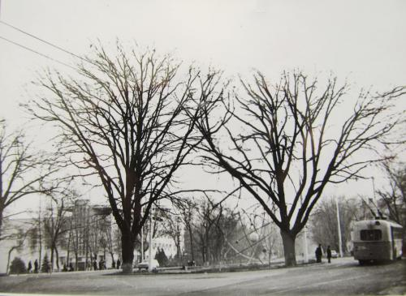
Сейчас · Bishkek


PISHPEK
No information has been found for this period yet
42.87701, 74.57909

Фотография пока не добавлена
ENGLISH
No information has been found for this period yet.

FRUNZE
Oaks
42.87701, 74.57909
Дубы · 60-х
ENGLISH Oaks
﻿ Oaks at the party congress. Photo of the 60s This street was named after the XXII Party Congress and Leninsky Prospect, and Stalin Street, and Grazhdanskaya Street, and also Kupecheskaya Street. Today it is Chui Avenue. Now in this place, on one side of Chui Avenue is the building of the National Academy of Sciences, on the other - the building of the National University, and between them along the street - a circular lawn and a lonely, already
Source: https://bimap.su/description/frunze/412_Atom.txt · BIMAP
Фотографии и материалы принадлежат их авторам; лицензия не указана

BISHKEK
No information has been found for this period yet
42.87701, 74.57909
Современный вид; дата публикации в 2GIS · Самара Арстанбекова
ENGLISH
No information has been found for this period yet.
Source: https://2gis.kg/bishkek/firm/70000001089231579/tab/photos · 2GIS
Фотография пользователя 2GIS; права принадлежат автору. Изображение показывается по внешней ссылке на 2GIS.

