ТОГДА / СЕЙЧАС
Панорама Фрунзе
42.87546, 74.61951
Тогда · Frunze
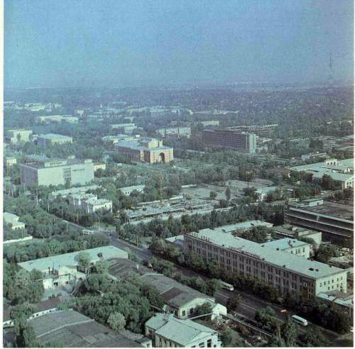
Сейчас · Bishkek


PISHPEK
No information has been found for this period yet
42.87546, 74.61951

Фотография пока не добавлена
ENGLISH
No information has been found for this period yet.

FRUNZE
Panorama of Frunze
42.87546, 74.61951
Панорама Фрунзе · 60-х
ENGLISH Panorama of Frunze
﻿ Panorama of Frunze. Photo of the 60s In the foreground on the left is the Hemp and Jute Factory, on the right is the Cholpon shoe company. In the center of the picture is the Central Department Store "Ai Churek", the Opera and Ballet Theater, the "Kyrgyzstan" hotel, the Central Market. The Cholpon shoe company produced about 6 million pairs of shoes a year, employing more than 4,000 people. The hemp and jute factory was founded in 1941 on the b
Source: https://bimap.su/description/frunze/408_Panorama.txt · BIMAP
Фотографии и материалы принадлежат их авторам; лицензия не указана

BISHKEK
No information has been found for this period yet
42.87546, 74.61951
Современный вид; дата публикации в 2GIS · Malika Isakova
ENGLISH
No information has been found for this period yet.
Source: https://2gis.kg/bishkek/firm/70000001100271882/tab/photos · 2GIS
Фотография пользователя 2GIS; права принадлежат автору. Изображение показывается по внешней ссылке на 2GIS.

