ТОГДА / СЕЙЧАС
Ресторан «Нарын»
42.88163, 74.61602
Тогда · Frunze
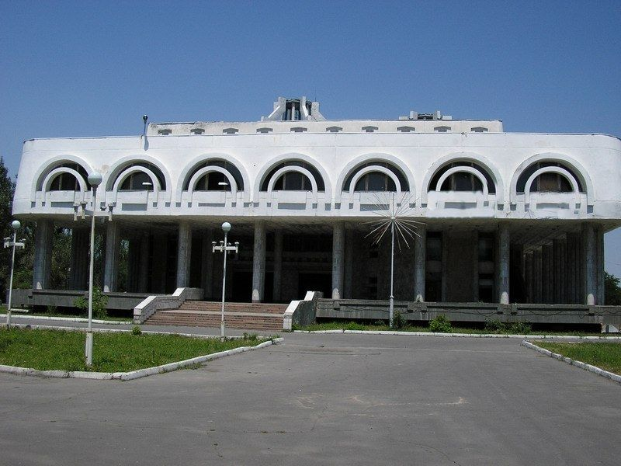
Сейчас · Bishkek


PISHPEK
No information has been found for this period yet
42.88163, 74.61602

Фотография пока не добавлена
ENGLISH
No information has been found for this period yet.

FRUNZE
Restaurant "Naryn"
42.88163, 74.61602
Ресторан «Нарын»
ENGLISH Restaurant "Naryn"
﻿ Restaurant "Naryn" Restaurant "Naryn". Architect V. Borovikov, Z. Shambetov, 1984.
Source: https://bimap.su/description/frunze/407_Naryn.txt · BIMAP
Фотографии и материалы принадлежат их авторам; лицензия не указана

BISHKEK
No information has been found for this period yet
42.88163, 74.61602
Фотография пока не добавлена
ENGLISH
No information has been found for this period yet.

