ТОГДА / СЕЙЧАС
Улица Советская
42.88118, 74.61166
Тогда · Frunze
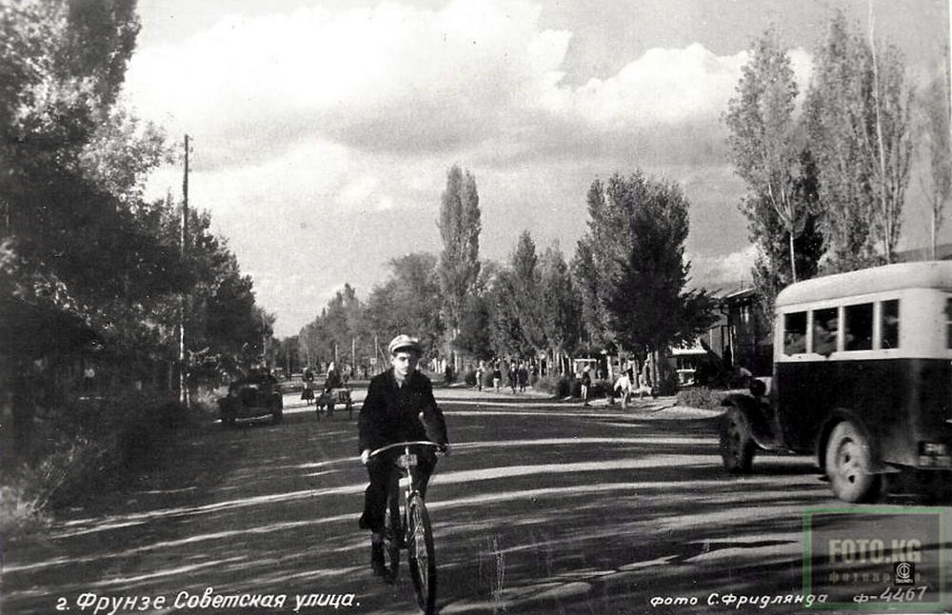
Сейчас · Bishkek


PISHPEK
No information has been found for this period yet
42.88118, 74.61166

Фотография пока не добавлена
ENGLISH
No information has been found for this period yet.

FRUNZE
Sovetskaya Street
42.88118, 74.61166
Улица Советская
ENGLISH Sovetskaya Street
﻿ Sovetskaya Street 1934 Sovetskaya Street (formerly Bazarnaya) began to be called in 1919. One of the central streets of the city. Here, between Tashkentskaya (Zhibek Zholu) and Koshchiynaya (Abdumomunova) streets, there were shops and shopping arcades.
Source: https://bimap.su/description/frunze/403_Sovetskaia.txt · BIMAP
Фотографии и материалы принадлежат их авторам; лицензия не указана

BISHKEK
No information has been found for this period yet
42.88118, 74.61166
Современный вид; дата публикации в 2GIS · Bek Myrza
ENGLISH
No information has been found for this period yet.
Source: https://2gis.kg/bishkek/geo/15763281595597581/tab/photos · 2GIS
Фотография пользователя 2GIS; права принадлежат автору. Изображение показывается по внешней ссылке на 2GIS.

