ТОГДА / СЕЙЧАС
Вид на высотку
42.82852, 74.59644
Тогда · Frunze
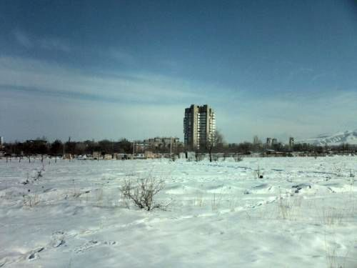
Сейчас · Bishkek


PISHPEK
No information has been found for this period yet
42.82852, 74.59644

Фотография пока не добавлена
ENGLISH
No information has been found for this period yet.

FRUNZE
View of the high-rise
42.82852, 74.59644
Вид на высотку
ENGLISH View of the high-rise
﻿ View of the high-rise in the 10th microdistrict View of the high-rise in the 10th microdistrict. Cooperative garages in front of the Ala-Archa River.
Source: https://bimap.su/description/frunze/391_Vysotka.txt · BIMAP
Фотографии и материалы принадлежат их авторам; лицензия не указана

BISHKEK
No information has been found for this period yet
42.82852, 74.59644
Фотография пока не добавлена
ENGLISH
No information has been found for this period yet.

