ТОГДА / СЕЙЧАС
Памятник К.И.Скрябину
42.85312, 74.60512
Тогда · Frunze
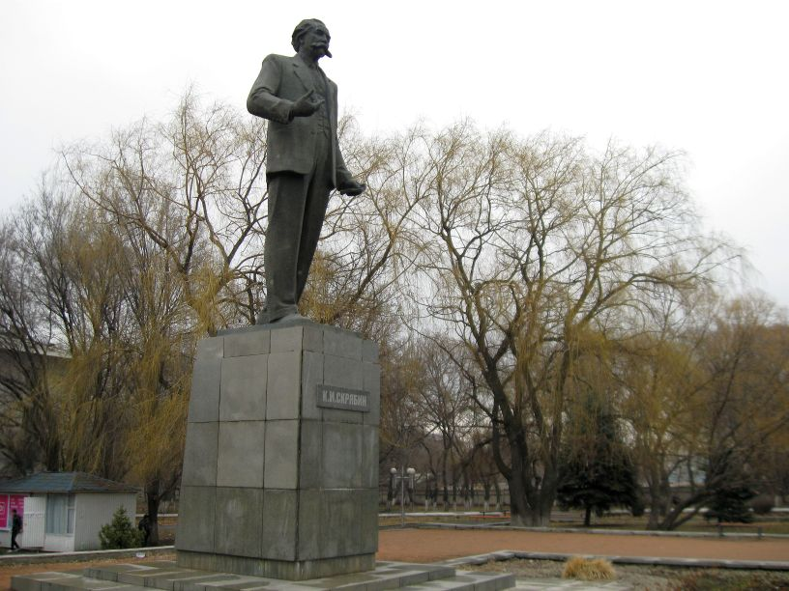
Сейчас · Bishkek


PISHPEK
No information has been found for this period yet
42.85312, 74.60512

Фотография пока не добавлена
ENGLISH
No information has been found for this period yet.

FRUNZE
Monument to K.I. Scriabin
42.85312, 74.60512
Памятник К.И.Скрябину
ENGLISH Monument to K.I. Scriabin
﻿ Monument to K.I. Scriabin Monument to K.I. Scriabin. Sculptor V. Shestopal, architect K. Sarabanov.
Source: https://bimap.su/description/frunze/390_Skriabin.txt · BIMAP
Фотографии и материалы принадлежат их авторам; лицензия не указана

BISHKEK
No information has been found for this period yet
42.85312, 74.60512
Фотография пока не добавлена
ENGLISH
No information has been found for this period yet.

