ТОГДА / СЕЙЧАС
Парадный вход в парк культуры «Карагачевая роща»
42.89155, 74.61517
Тогда · Frunze
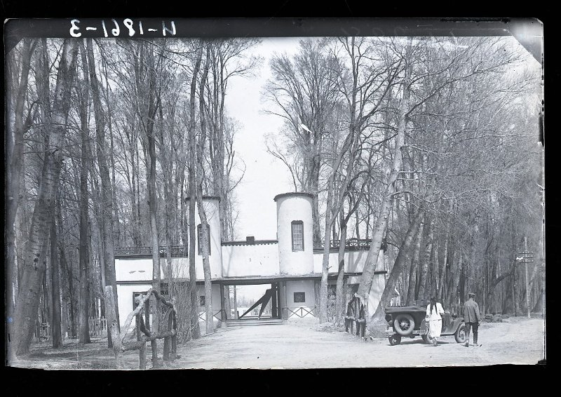
Сейчас · Bishkek


PISHPEK
No information has been found for this period yet
42.89155, 74.61517

Фотография пока не добавлена
ENGLISH
No information has been found for this period yet.

FRUNZE
The main entrance to the Karagachevaya Roshcha cultural park
42.89155, 74.61517
Парадный вход в парк культуры «Карагачевая роща»
ENGLISH The main entrance to the Karagachevaya Roshcha cultural park
The main entrance to the Karagachevaya Roshcha cultural park In 1935, the “Park of Culture and Recreation” was organized in the Karagachevaya Roshcha. Paths were laid here, flower beds were laid out, a dance floor and fountains were built. The entrance to the park from Alma-Atinskaya (Usenbaeva) Street was decorated with a monumental arch, where shopping kiosks, a chess club, and a reading room were located. Behind the huge gates, the Frunzenian
Source: https://bimap.su/description/frunze/378_Karagachi.txt · BIMAP
Фотографии и материалы принадлежат их авторам; лицензия не указана

BISHKEK
No information has been found for this period yet
42.89155, 74.61517
Фотография пока не добавлена
ENGLISH
No information has been found for this period yet.

