ТОГДА / СЕЙЧАС
Пишпекский базар
42.88140, 74.61256
Тогда · Pishpek
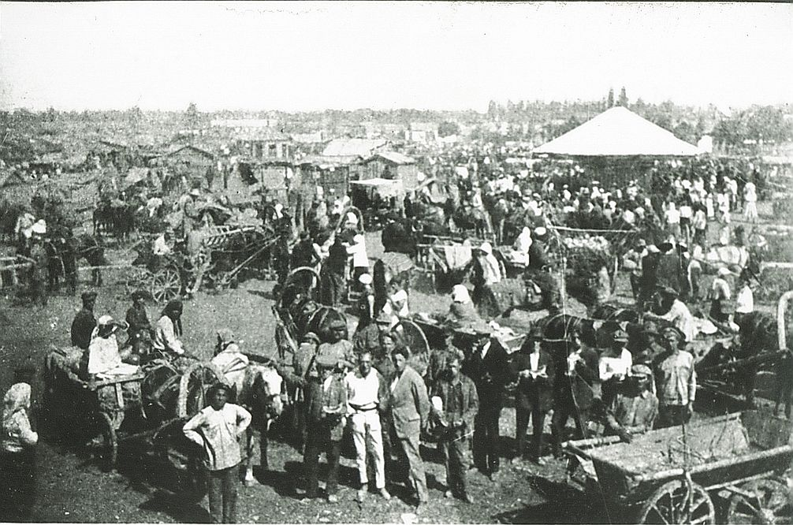
Сейчас · Bishkek


PISHPEK
Pishpek Bazaar
42.88140, 74.61256
Пишпекский базар
ENGLISH Pishpek Bazaar
﻿ Pishpek Bazaar. In the foreground are members of the Intergelpo cooperative, 1926. The main urban object in Pishpek was the bazaar adjacent to the central part of the city. At first, several adobe and wooden benches were located along its borders. They sold grain and flour, and there was also a meat aisle. The Dungans delivered cheap vegetables, rice, red pepper, and garlic to the market. Vegetables and fresh fruits, livestock products and live
Source: https://bimap.su/description/pishpek/58_Intergelpo_na_bazare1926.txt · BIMAP
Фотографии и материалы принадлежат их авторам; лицензия не указана

FRUNZE
No information has been found for this period yet
42.88140, 74.61256

Фотография пока не добавлена
ENGLISH
No information has been found for this period yet.

BISHKEK
No information has been found for this period yet
42.88140, 74.61256
Фотография пока не добавлена
ENGLISH
No information has been found for this period yet.

