ТОГДА / СЕЙЧАС
Павильон
42.87466, 74.57049
Тогда · Frunze
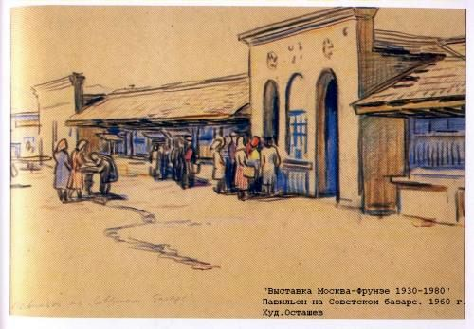
Сейчас · Bishkek


PISHPEK
No information has been found for this period yet
42.87466, 74.57049

Фотография пока не добавлена
ENGLISH
No information has been found for this period yet.

FRUNZE
Pavilion
42.87466, 74.57049
Павильон
ENGLISH Pavilion
﻿ Pavilion at the Soviet Bazaar Ostashev. Pavilion at the Soviet Bazaar, 1960.
Source: https://bimap.su/description/frunze/372_Ostashov.txt · BIMAP
Фотографии и материалы принадлежат их авторам; лицензия не указана

BISHKEK
No information has been found for this period yet
42.87466, 74.57049
Фотография пока не добавлена
ENGLISH
No information has been found for this period yet.

