ТОГДА / СЕЙЧАС
Общежитие Комвуза
42.88096, 74.60517
Тогда · Frunze
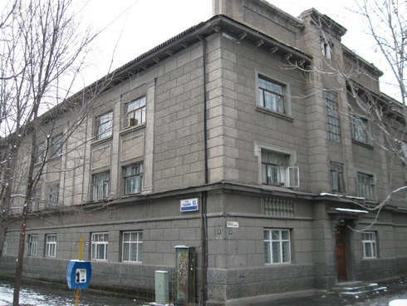
Сейчас · Bishkek


PISHPEK
No information has been found for this period yet
42.88096, 74.60517

Фотография пока не добавлена
ENGLISH
No information has been found for this period yet.

FRUNZE
Komvuz dormitory
42.88096, 74.60517
Общежитие Комвуза · Владимира Петрова
ENGLISH Komvuz dormitory
﻿ Komvuz dormitory Komvuz dormitory. Architect Yu. Dubov, 1938. During the war, the 1266th Masurian Rifle Regiment of the 385th Rifle Division was formed here, and the dormitory of the Odessa Aviation School was located. Then there was a Soviet party school here.
Source: https://bimap.su/description/frunze/371_Sovpartshkola.txt · BIMAP
Фотографии и материалы принадлежат их авторам; лицензия не указана

BISHKEK
No information has been found for this period yet
42.88096, 74.60517
Фотография пока не добавлена
ENGLISH
No information has been found for this period yet.

