ТОГДА / СЕЙЧАС
Мураталы Куренкеев
42.86989, 74.59980
Тогда · Frunze
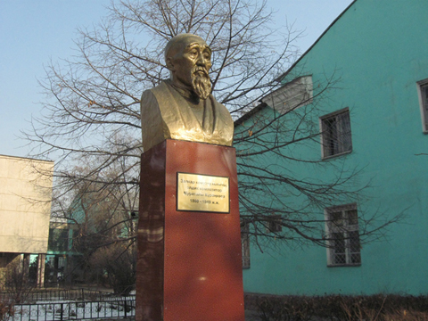
Сейчас · Bishkek


PISHPEK
No information has been found for this period yet
42.86989, 74.59980

Фотография пока не добавлена
ENGLISH
No information has been found for this period yet.

FRUNZE
Murataly Kurenkeyev
42.86989, 74.59980
Мураталы Куренкеев · Владимира Петрова
ENGLISH Murataly Kurenkeyev
﻿ Murataly Kurenkeyev A bust of Murataly Kurenkeyev is installed near the building of the music school. Sculptor Olga Manuilova, 1959.
Source: https://bimap.su/description/frunze/370_Kurenkeev.txt · BIMAP
Фотографии и материалы принадлежат их авторам; лицензия не указана

BISHKEK
No information has been found for this period yet
42.86989, 74.59980
Фотография пока не добавлена
ENGLISH
No information has been found for this period yet.

