ТОГДА / СЕЙЧАС
Западная сторона бульвара Дзержинского
42.88251, 74.60644
Тогда · Frunze
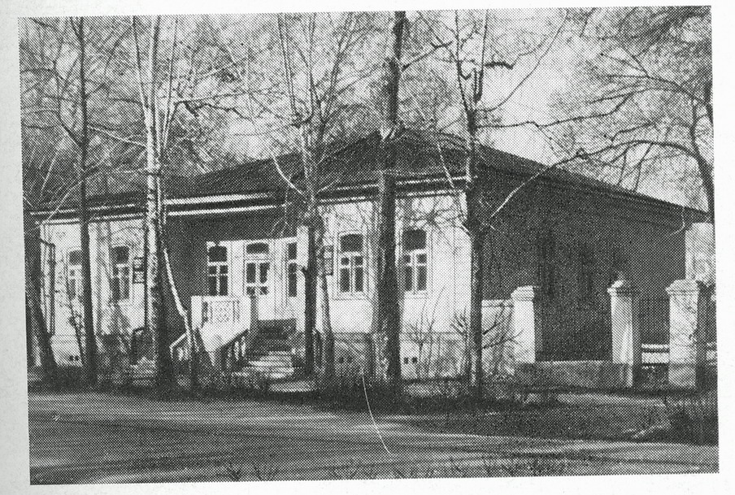
Сейчас · Bishkek


PISHPEK
No information has been found for this period yet
42.88251, 74.60644

Фотография пока не добавлена
ENGLISH
No information has been found for this period yet.

FRUNZE
Western side of Dzerzhinsky Boulevard
42.88251, 74.60644
Западная сторона бульвара Дзержинского
ENGLISH Western side of Dzerzhinsky Boulevard
﻿ Western side of Dzerzhinskaya Street This bourgeois house built at the end of the 19th - early 20th centuries was used as a clinic during Soviet times. In modern times, the US Embassy was located there.
Source: https://bimap.su/description/frunze/365_DomBulvarnoi.txt · BIMAP
Фотографии и материалы принадлежат их авторам; лицензия не указана

BISHKEK
No information has been found for this period yet
42.88251, 74.60644
Фотография пока не добавлена
ENGLISH
No information has been found for this period yet.

