ТОГДА / СЕЙЧАС
Мединститут
42.87070, 74.59642
Тогда · Frunze
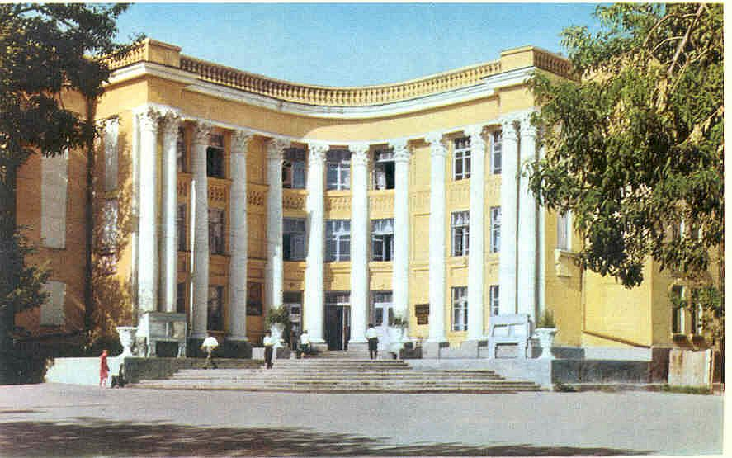
Сейчас · Bishkek


PISHPEK
No information has been found for this period yet
42.87070, 74.59642

Фотография пока не добавлена
ENGLISH
No information has been found for this period yet.

FRUNZE
Medical Institute
42.87070, 74.59642
Мединститут
ENGLISH Medical Institute
﻿ Medical Institute Medical Institute. Architects F.P. Steblin, S.Kh. Sahakyan, 1939. Today it seems strange that such a spectacular building with its facade with graceful columns looks into the courtyard. This did not happen due to an erroneous connection. In the 40s, Logvinenko Street served as the main exit from the city to the south towards the mountains. The street was lined with educational and administrative buildings, and in front of the
Source: https://bimap.su/description/frunze/363_Medinstitut.txt · BIMAP
Фотографии и материалы принадлежат их авторам; лицензия не указана

BISHKEK
No information has been found for this period yet
42.87070, 74.59642
Фотография пока не добавлена
ENGLISH
No information has been found for this period yet.

