ТОГДА / СЕЙЧАС
Торговые ряды
42.88144, 74.61154
Тогда · Pishpek
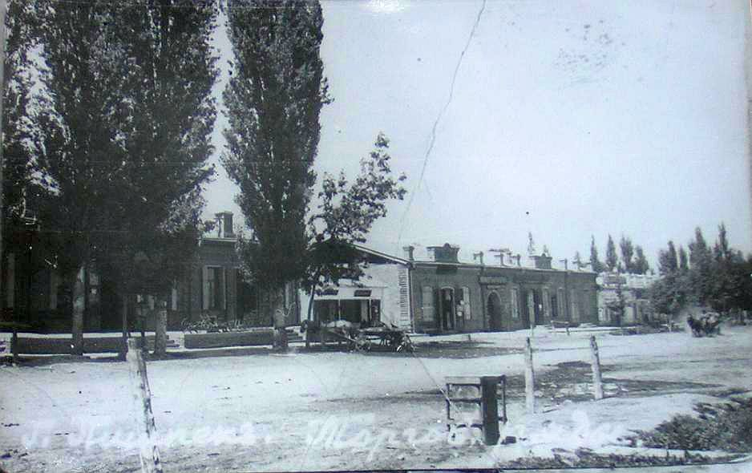
Сейчас · Bishkek


PISHPEK
Shopping arcades
42.88144, 74.61154
Торговые ряды
ENGLISH Shopping arcades
﻿ Shopping arcades on Bazarnaya Street, 1910. Shopping arcades were lined with a continuous series of shops and stores. The shops of prominent merchants were built of baked bricks with characteristic patterned and rusticated masonry. The cornices ended with figured pediments, turrets, and pedestals. The roofs were covered with iron. Large window and door openings were closed from the outside with forged metal shutters.
Source: https://bimap.su/description/pishpek/57_Riady_Bazarnoi1910.txt · BIMAP
Фотографии и материалы принадлежат их авторам; лицензия не указана

FRUNZE
No information has been found for this period yet
42.88144, 74.61154

Фотография пока не добавлена
ENGLISH
No information has been found for this period yet.

BISHKEK
No information has been found for this period yet
42.88144, 74.61154
Фотография пока не добавлена
ENGLISH
No information has been found for this period yet.

