ТОГДА / СЕЙЧАС
Лекрастрест
42.86246, 74.60470
Тогда · Frunze
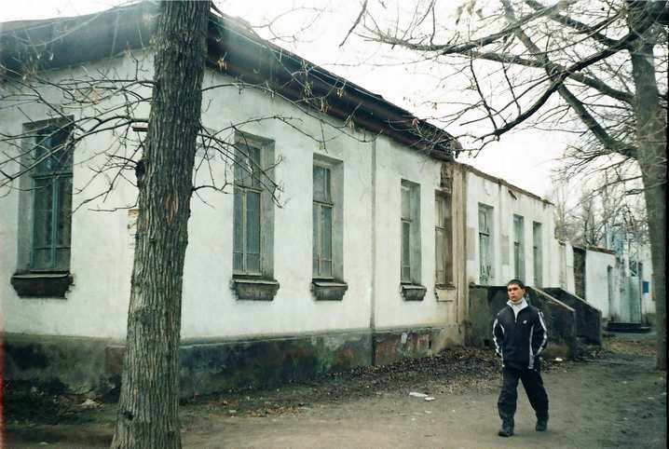
Сейчас · Bishkek


PISHPEK
No information has been found for this period yet
42.86246, 74.60470

Фотография пока не добавлена
ENGLISH
No information has been found for this period yet.

FRUNZE
Lekrastrest
42.86246, 74.60470
Лекрастрест · Владимира Петрова
ENGLISH Lekrastrest
﻿ Lekrastrest The last days of Lekrastrest. Photo by Vladimir Petrov. Lecratrust was created in 1930. The buildings were built in 1935. Lekrastrest was engaged in collecting medicinal plants and processing plant raw materials. But the main occupation was the procurement of raw opium. Natural climatic conditions contributed to the cultivation of poppy with a high content of morphines in Kyrgyzstan. In the 1950-1960s, the republic produced 16% of t
Source: https://bimap.su/description/frunze/361_Lekartrest.txt · BIMAP
Фотографии и материалы принадлежат их авторам; лицензия не указана

BISHKEK
No information has been found for this period yet
42.86246, 74.60470
Фотография пока не добавлена
ENGLISH
No information has been found for this period yet.

