PISHPEK
No information has been found for this period yet
42.87182, 74.59835

Фотография пока не добавлена
ENGLISH
No information has been found for this period yet.

FRUNZE
Baths
42.87182, 74.59835
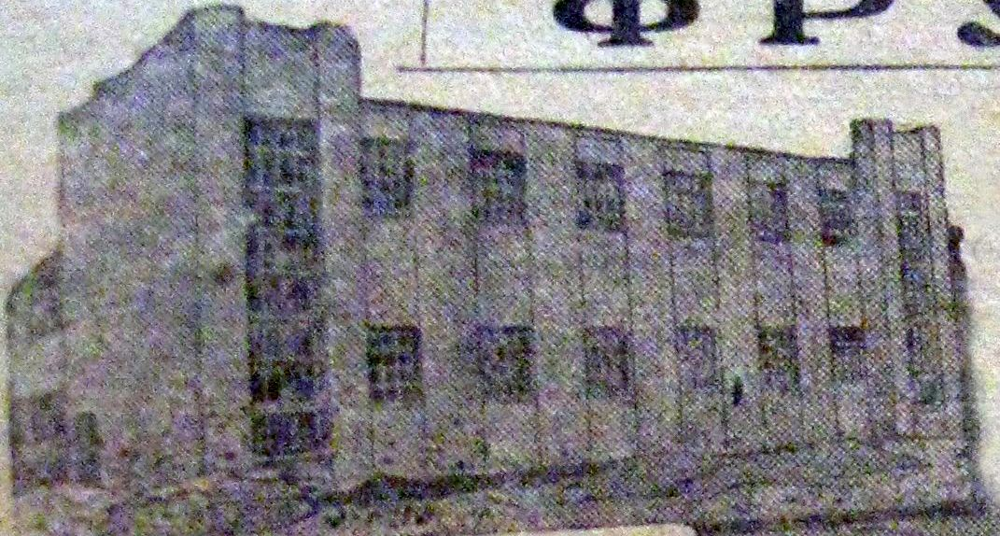
Бани
ENGLISH Baths
﻿ Baths, Photo from a 1932 newspaper Baths, Photo from a 1932 newspaper. The opening of public baths on Bolnichnaya Street (Logvinenko), at that time the largest in Central Asia, ended the basin washing period for the townspeople. Now they washed themselves in the same basins, but in the bathhouse the basins were called gangs. And the line for washing moved forward as these gangs were released, the receipt of which was accompanied by the issuance
Source: https://bimap.su/description/frunze/359_Bani1932.txt · BIMAP
Фотографии и материалы принадлежат их авторам; лицензия не указана

BISHKEK
No information has been found for this period yet
42.87182, 74.59835

Фотография пока не добавлена
ENGLISH
No information has been found for this period yet.

