PISHPEK
No information has been found for this period yet
42.88437, 74.60058

Фотография пока не добавлена
ENGLISH
No information has been found for this period yet.

FRUNZE
Monument to Lenin
42.88437, 74.60058
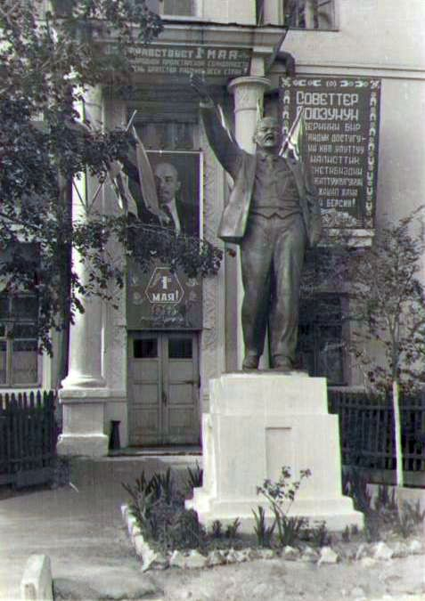
Памятник Ленину · 1958 года
ENGLISH Monument to Lenin
﻿ Monument to Lenin near the cooperative technical school. Photo from 1958 The Frunze Cooperative Technical School was opened on October 4, 1930. At that time, the educational institution was called the collective farm-cooperative technical school, and in 1931 it was renamed the cooperative technical school. In 1932, the Kyrgyzpotrebsoyuz built this new educational building. In 1943, the technical school was transferred to Tokmak. In 1944, he ret
Source: https://bimap.su/description/frunze/358_Lenin_koop.txt · BIMAP
Фотографии и материалы принадлежат их авторам; лицензия не указана

BISHKEK
No information has been found for this period yet
42.88437, 74.60058

Фотография пока не добавлена
ENGLISH
No information has been found for this period yet.

