PISHPEK
No information has been found for this period yet
42.87962, 74.61487

Фотография пока не добавлена
ENGLISH
No information has been found for this period yet.

FRUNZE
Teahouse
42.87962, 74.61487
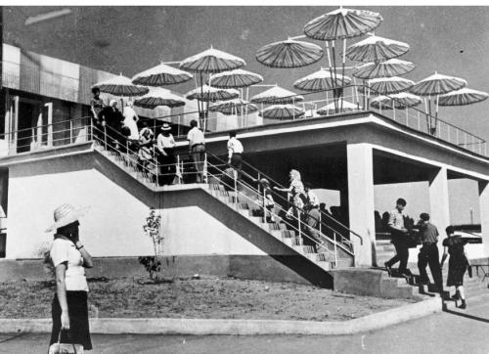
Чайхана
ENGLISH Teahouse
﻿ Teahouse near the market Teahouse near the market.
Source: https://bimap.su/description/frunze/356_Chaihana.txt · BIMAP
Фотографии и материалы принадлежат их авторам; лицензия не указана

BISHKEK
No information has been found for this period yet
42.87962, 74.61487

Фотография пока не добавлена
ENGLISH
No information has been found for this period yet.

